
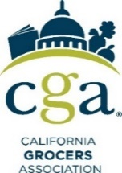
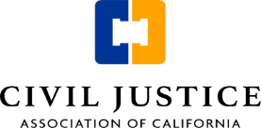

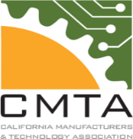

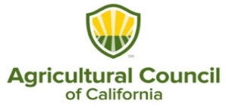
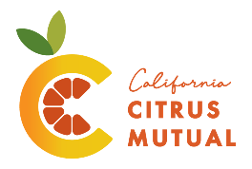
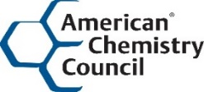


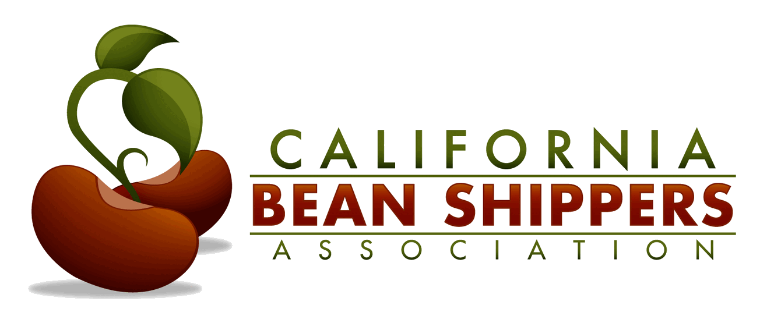
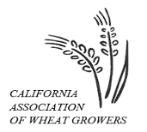
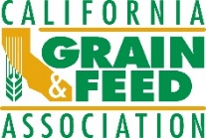


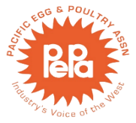
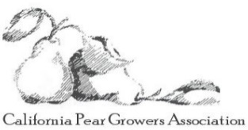

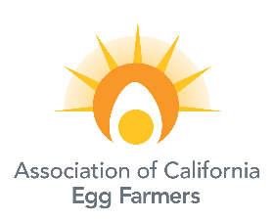

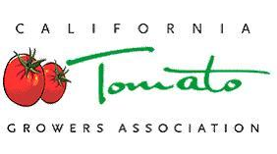


June 10, 2025

The Honorable Sasha Renée Pérez, Chair
Senate Education Committee
1021 O Street, Suite 6740
Sacramento, CA 95814

RE: AB 1264 (Gabriel) “Ultraprocessed Foods” - Oppose Unless Amended

Dear Senator Pérez,

On behalf of the undersigned organizations representing food and beverage manufacturers, dairy interests and suppliers, the agricultural industry, and more, we write to express our opposition to Assembly Bill 1264 (AB 1264) unless it is amended to address our concerns. While the bill’s intent to improve student nutrition is commendable, the bill is overly broad and would apply to all food and beverages through an unscientific, litigious, and costly process that will burden schools, confuse consumers, and increase food costs. AB 1264 introduces significant financial and administrative burdens on school districts and the State Department of Education, which will result in fewer products being available, higher costs, and reduced choice.

AB 1264 mandates the unscientific and arbitrary categorization and stigmatization of "ultraprocessed" foods, with an overinclusive definition that captures many commonly used ingredients in school meal staples and natural products, including corn starch, egg whites, natural colors, and products like beet juice or mustard seed. It also passes over the critical fact that food ingredients have distinct purposes of maintaining or improving 1) safety or freshness, 2) nutritional value, and 3) taste and texture of food. This categorization is a “scarlet letter” on nutritious and safe foods that extends beyond the context of schools, as the bill adds this definition to the Health and Safety Code instead of the Education Code.

The bill also establishes a burdensome and redundant process at OEHHA that would result in certain ingredients being categorized as “particularly harmful ultraprocessed foods.” There is an existing regulatory process under Health and Safety Code 110070 that authorizes the Department of Public Health, “upon its own motion, or upon any interested party,” to require the department to review these ingredients and restrict or prohibit the use of any “food additives… or color additives.” Why implement an entirely duplicative process at another agency with little expertise in food additives? If modernizing this section is required, we suggest updating it, not creating another burdensome and undefined process at an agency without expertise.

Below is more information about a few of the key concerns with AB 1264:

Lack of Scientific Definitions – There is currently no agreed upon scientific definition of ultraprocessed foods. Attempting to classify foods as unhealthy simply because they are processed, or demonizing food by ignoring its full nutrient content, misleads consumers and exacerbates health disparities.

Earlier this year, the Dietary Guidelines for Americans (DGA) Advisory Committee determined that “there is a lack of clear evidence and a need for more rigorous scientific studies” before the use of ultra-processed foods can be included in the DGAs. Any potential conclusion from the DGA Advisory Committee on the relationship between dietary patterns and “ultra-processed foods” would be premature and inconsistent with the requirements that the Dietary Guidelines be based on the current body of nutrition science; this was affirmed by the Committee, which found that evidence linking growth, body composition, and risk of obesity with ultra-processed foods was limited.

If the DGA Advisory Committee, comprised of internationally known experts, was unable to find a workable definition of ultraprocessed foods, it is difficult to imagine how the legislature can designate one and expect an agency with little food or nutrition experience to build a upon it. The result will be an exponentially skewed and likely unworkable definition and process to result in higher costs to consumers without the corresponding public health outcomes the bill is purportedly seeking. Simply, with no scientific definition of ultraprocessed food, it is impossible for OEHHA to establish a definition of “particularly harmful ultra-processed food.”

Opening the Door to Costly Lawsuits and Diverted School Resources - By introducing vague and inflammatory definitions of “ultraprocessed” and “particularly harmful ultraprocessed foods,” AB 1264 exposes school districts and food vendors to a surge in costly litigation. This legal uncertainty will compel schools to redirect limited funds away from classroom instruction and nutritious, locally grown meals to cover legal expenses. Recent lawsuits brought by special interest groups, such as those involving Poway USD, LAUSD, and the State Department of Education, demonstrate that even when schools prevail, the costs of legal defense are substantial. Unlike the coalition’s targeted ingredient review proposal, AB 1264’s subjective and sweeping language significantly increases legal exposure.

Statewide and National Disruptions to School Meal Programs – The federal government continues to take aggressive action with school meals and across the food

chain through the United States Department of Agriculture (USDA). In April 2024, the USDA finalized long-term school nutrition standards, effective July 1, 2024, phasing in changes, including limits on added sugars and sodium, increased whole grains, and added flexibility for schools in offering breakfast options. Specifically, the new rules limit added sugar in school meals, particularly in breakfast cereals and yogurt, and flavored milk and imposes both product-based limits and a weekly dietary limit for sugars and sodium.

The USDA provides the predominant share of funding, and new state specific requirements such as what AB 1264 proposes are not likely to be federally reimbursed or could limit the availability of USDA commodities. A state-by-state regulatory framework on processed foods could drive up costs and create inconsistencies in food availability, placing additional strain on school nutrition professionals.

Increased Administrative and Financial Burdens – The bill requires the Office of Environmental Health Hazard Assessment (OEHHA) and the Department of Education (DoE) to produce extensive reports and conduct ongoing evaluations, adding significant staffing and compliance costs.

Reduced Food Variety and Increased Costs – Suppliers will be forced to reformulate recipes using less and more costly ingredients, potentially limiting meal options and increasing procurement costs for school districts already facing budgetary constraints.

Misalignment with Existing Regulations and Waste Reduction Goals – Many of the ingredients the bill may prohibit provide longer shelf life and extend freshness. The bill does not clearly align with current school meal guidelines and could negatively impact districts’ efforts to minimize food waste.

An Alternative Approach: Review School Meal Ingredients for Safety

The stated intent of the author is to protect school children from unhealthy ingredients and to improve school nutrition. While we believe the Dietary Guidelines for Americans and the USDA school nutrition regulatory development process is adequate and benefits all students with a uniform nutrition policy, we recognize the author’s desire to go further for Californians. For policy discussion purposes, we would suggest two-part approach to 1) review California’s school nutrition standards and determine if additional changes are warranted; and 2) enhance the existing ingredient review process.

Below is more information about our proposal to accomplish the stated intent of AB 1264 to improve pupil nutrition:

Focus on Nutritional Standards - We recommend improving California’s nutrition standards through a rulemaking process similar to the USDA’s federal school nutrition program, prioritizing studies on the impact of recent reductions in fat, sodium, and added sugars. Additionally, increasing whole grain content and exploring other nutritional categories such as fiber and protein should be key focus areas.

Incentive Purchase and Inclusion of California Grown Products - Provide a purchasing incentive for CA Grown or Processed Products.

Enhance Ingredient Review via Health and Safety Code 110070 - The FDA is the nation’s food safety agency, and they maintain a public inventory of all substances added to food. Regardless, if California has concerns about specific ingredients, we strongly encourage the state food safety experts to work with the federal food safety agency to prioritize a post market assessment and identify a transparent process for identifying and prioritizing food ingredients currently in the market for safety reviews. While we believe the aforementioned areas of focus should be a priority, we none-the-less offer the following for policy discussion purposes (while maintaining our firm commitment and sufficiency of the FDA’s current science and risk based process): California school nutrition substance / ingredient review pursuant to Health and Safety Code Section 110070. That process could include enhanced timelines and consultation other agencies with food safety expertise.

For these reasons, we urge you to oppose AB 1264 until it is amended into a scientifically guided and workable process as suggested above. Our coalition is committed to working with legislators to develop balanced, effective, and sustainable policies that support student health and school operations alike.

Sincerely,


Erin Raden
Senior Director, State Affairs
Consumer Brands Association


Tricia Geringer
Vice President of Government Affairs
Agricultural Council of California


Tim Shestek
Senior Director, State Affairs
American Chemistry Council
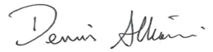

Dennis Albiani
President, California Advocates
on behalf of American Beverage Association
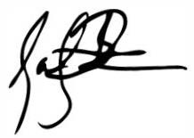

Zachary Fraser
President & CEO
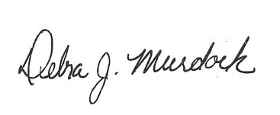
American Pistachio Growers

Debbie Murdock
Executive Director
Association of California Egg Farmers


Brooke Palmer
Executive Officer
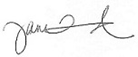
California Association of Wheat Growers

Jane Townsend
Executive Officer
California Bean Shippers Association

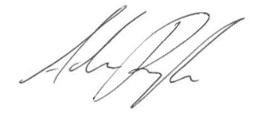

Adam Regele
Vice President of Advocacy and Strategic Partnerships

California Chamber of Commerce

Casey Creamer
President/CEO
California Citrus Mutual


Chris Reardon
Vice President of Policy Advocacy
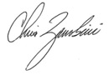
California Farm Bureau

Chris Zanobini
Chief Executive Officer
California Grain and Feed Association


Daniel Conway
Vice President, Government Relations

California Grocers Association

Trudi Hughes
President and CEO

California League of Food Producers

Elizabeth Esquivel
Vice President of Government Relations
California Manufacturers & Technology Association

Debbie Murdock
President
California Pear Growers Association
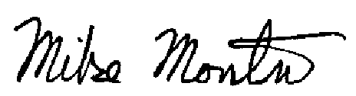

Mike Montna
President/CEO
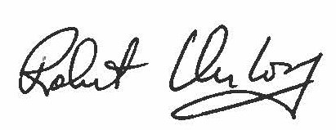
California Tomato Growers Association

Robert Verloop
Executive Director/CEO
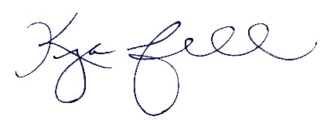
California Walnut Commission

Kyla Christoffersen Powell
President and Chief Executive Officer
Civil Justice Association of California
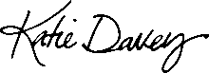

Katie Davey
Executive Director
Dairy Institute of California

Debbie Murdock
Executive Director
Pacific Egg & Poultry Association
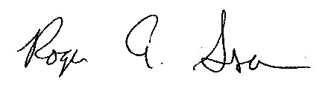

Roger Isom
President/CEO
Western Tree Nut Association

cc: Assemblymember Jesse Gabriel
Lynn Lorber, Chief Consultant and Staff Director, Senate Education Committee
Amanda Richie, Policy Consultant, Senate Republican Caucus

