Estimating the cost implications of reducing plastic packaging for fresh produce

Table of contents
- Final report
  - Authors
  - Suggested citation
- Executive summary
- Introduction
- Purpose and objectives
  - Project scope
  - In-scope research considerations
  - Out-of-scope considerations
- Literature review
  - Chosen fruits and vegetables
  - Scientific and industry literature
- Primary research
  - Retail audits
  - Modelling cost implications of change
  - Summarized findings from industry consultations
  - Cost analysis and implications
- Recommendations and future research
  - Reusable plastic crates
  - Alternative packaging
- Conclusions
- Appendix A: Reusable plastic crates
- Appendix B: Discussion guide
- Appendix C: Comparative functional performance
- Bibliography
- Notes

List of tables
- Table 3-1: Comparative opportunities for change by produce category
- Table 3-2: Modelled changes in proportion sold prepacked in plastic, proportion imported
- Table 4-1: Summary of fresh fruit and vegetable merchandizing formats found in 4 UK retail stores
- Table 4-2: Summary of fresh fruit and vegetable merchandizing formats found in 6 Canadian retail stores
- Table 4-3: Viability of increasing the proportion of total sales sold in alternative packaging
- Table 4-4: Viability of increasing the proportion of total sales sold loose
- Table 4-5: Simple scenario-impact of higher material cost on consumer price
- Table 4-6: Estimated current packaging cost as a proportion of retail price
- Table 4-7: Cost implications from a value chain perspective
- Table 5-1: Perceived barriers and potential opportunities of RPC adoption
- Table 5-2: Alternative packaging design, test, commercialize process

List of figures
- Figure 3-1: Alternatives to single-use plastics
- Figure 4-1: Value chain map of process step, costs, performance metric
- Figure 4-2: Cost implications associated with the transition to alternative packaging
- Figure 4-3: Cost implications associated with transitioning to RPCs for alternative packaging
- Figure 4-4: Cost implications associated with transitioning to RPCs for loose produce

Final report
March 7, 2025

Authors
- Martin Gooch, PhD
- Delia Bucknell
- Loong-Tak Lim, PhD*
- Dan LaPlain
- Peter Whitehead, PhD

Suggested citation
Gooch, M., Bucknell, D., Lim, L-T., LaPlain, D., Whitehead, P. 2024. Estimating the Cost Implications of Reducing Plastic Packaging for Fresh Produce; Value Chain Management International.
*Loong-Tak Lim is a Professor in the Department of Food Science at the University of Guelph, Ontario, Canada.

Executive summary
Packaging plays a crucial role in enabling the Canadian fresh produce industry to operate effectively and efficiently. It protects products throughout the value chain, aiding transportation and logistics. All of these and other factors are vital given that Canada imports approximately three-quarters of the fresh produce consumed, and the thousands of kilometres over which much of this produce is transported.
Three forms of packaging exist: primary, secondary and tertiary. Primary packaging is that which is in direct contact with food and which consumers take home. It is the primary focus of the proposed study. The potential for transitioning from cardboard cartons to reusable plastic crates (RPCs) was the only aspect of secondary and tertiary packaging that fell within the scope of this study. For the purpose of this study, alternative packaging refers to packaging that is partially or fully manufactured from paper and fibre. This includes multi-material packaging, such as cardboard bases with a plastic top seal or inspection window that can be easily separated to allow the packaging components to be easily recycled.
The purpose of the project was to better understand the cost implications and/or benefits associated with reducing primary plastic packaging for fresh produce sold in Canada without risking unintended consequences that outweigh benefits achieved. This was accomplished by researching the net cost/ benefit implications of reducing non-essential plastic packaging for 6 fruits and vegetables (that is, lemons, apples, grapes, onions, carrots, and tomatoes) to generate findings that can be inferred across the wider industry.
The study reviewed 3 options for reducing plastic packaging in fresh produce, namely:
- Eliminating primary plastic packaging for hardy produce
- Using alternative, non-plastic packaging
- Transitioning to RPCs in place of cardboard cartons, for loose and packaged produce
The project began by the reviewing of conclusions drawn from a prior Value Chain Management International Inc (VCMI) study completed in April 2024, along with scientific, industry and trade literature, to determine 1) the 6 fruits and vegetables on which the study would focus; 2) conclusions drawn from scientific studies into alternative packaging materials for fruits and vegetables; 3) evidence of alternative packaging that has been successfully introduced at commercial scale; 4) evidence of cost/benefit implications associated with the elimination of plastic packaging in favour of selling loose or packed in alternative packaging; and 5) a transition from cardboard cartons to RPCs. If also transitioning from packaged to loose, RPCs offer the potential to simultaneously replace both primary and secondary plastic packaging. Informal exploratory discussions were also conducted with 13 industry experts.
This review identified that considerable research has been undertaken to develop alternative materials suited to fresh fruits and vegetables. Analysts say it is possible to replace a high proportion (around 45%) of plastic packaging utilized by the food industry, though financial and structural challenges limit the industry's ability to achieve widespread change in the short to medium term. Multiple examples of paper and fibre-based packaging have been introduced with varying levels of commercial success. Most of these transitions have taken place in premium items targeted at distinct segments of the market.
A pathway to increasing the proportion of fresh produce sold loose in the United Kingdom (UK) has been proposed by the Waste and Resources Action Programme (WRAP). With a higher proportion of fresh produce sold in the UK being packaged in plastic compared to Canada, the applicability of the UK's approach to Canada may be somewhat limited. While a high proportion of consumers voice an interest in purchasing loose in developed markets, such as Canada, US and the UK, for a variety of reasons, that voiced intent does not translate into purchasing practices.
While purchasing loose allows consumers to only buy what they want, potentially resulting in reduced food waste (particularly in small households), respondents stated a number of reasons deter consumers from choosing loose ahead of prepackaged. As also cited in the literature review, such reasons include a perceived lack of quality, hygiene concerns, confusion regarding the cost of individual items versus packaged items, and the convenience of picking up a package. In addition, the sale of loose produce requires more retail staff to maintain sales and minimize shrink by ensuring displays are managed correctly. This, along with potential pack house inefficiencies, can result in the same volume of loose fresh produce often costing consumers more than that which has been prepacked. The financial benefit of loose therefore rests on consumers' purchasing only what they need, thereby saving money overall.
Store audits conducted at major UK and Canadian retailers identified that, with the exception of grapes, all of the visited retailers offered the studied items in both loose and prepackaged formats. The audits found that, while alternative packaging has been trialled for multiple products in the UK and Canadian retail environments, its widespread commercial adoption remains a challenge. A key difference between the 2 markets is that UK retailers have adopted one-touch merchandizing practices for both loose and prepackaged fresh produce, largely relying on the use of RPCs (reusable plastic crates). In contrast, the vast majority of loose and prepackaged fresh produce in Canadian stores is manually placed as individual units on retail shelves. This practice leads to higher operational and labour costs and increased shrink, due to additional handling and the potential for damage while the produce is on display.
The importance consumers place on inspecting produce prior to purchase was highlighted by respondents possessing first-hand experience of declined sales when products were packaged in alternative (non-transparent) materials that limited visibility. This decline occurred regardless of whether the packaging change was accompanied by a price increase. Solutions to address consumer aversion to purchasing fresh produce in non-transparent materials exist, but they require time and financial resources to implement.
Three key factors were consistently present in cases where switching to alternative packaging materials resulted in a measurable increase in sales: 1) the appearance of the packaging had not markedly changed from the existing packaging, 2) the packaging enhanced the product's overall value proposition, and 3) consumers could inspect a representative sample of the produce prior to purchase. In most cases, the prices of these items were similar or had not increased by more than 10% compared to what consumers previously paid.
Almost all of the study respondents expressed a desire to reduce the proportion of fresh produce packaged in plastic, where feasible. While transitioning to loose could reduce suppliers' packaging costs, for reasons cited in the literature review and by respondents, the overall cost implications of the operational inefficiencies associated with loose (particularly that incurred by retailers) will often translate to an increase in prices paid by consumers.
Using apples as the basis of the costing analysis for loose versus packaged, because it allowed UK and Canadian insights to be compared to empirical research completed in Germany, the study identified that the average price by weight for loose apples can be 24, 39 and 32% higher (UK, CA, Germany respectively) than packed apples. Based on a bag of apples weighing 3 pounds (1.36 kg), the point at which Canadian consumers would benefit financially from purchasing loose are those (consumers) wanting to purchase 47% fewer apples (by weight). This comparison ignores size, quality and source considerations.
The cost implications of transitioning to alternative packaging materials extend beyond the differences in the cost of the packaging materials. Potentially, the lowest cost implication is where a transition to alternative packaging does not require reengineering of the packing line and the new packaging is of similar size and shape to the existing one. An example is packing tomatoes in a paper or fibre base with a top plastic seal, versus the current plastic base with a plastic top seal. If packaging material costs are passed along, the cost implication of such a transition could equate to a low double digit increase in retail price (for example, 11%).
The greatest cost implication of transitioning to alternative packaging is in lower-value commodities by weight that require much different packaging from what is currently used. For example, replacing a low-cost plastic bag with a more expensive cardboard box. This transition would require substantial investments in equipment and facilities. Without investments in capital, equipment and processing capacity, high velocity automated packing is impossible. The implications of such a transition could equate to a approximately 42% increase in retail price.
If the adoption of RPCs enabled supply chain efficiencies similar to those achieved in Europe and the UK — where reductions in distribution, merchandizing, and in-store labour related costs were realized — then, conceptually, these efficiency gains could offset some of the cost implications associated with transitioning fresh produce to alternative packaging. The ($/kg) difference in average prices of apples purchased loose versus packaged was found to be less in the UK than Germany or Canada, which suggests that retailers are passing benefits attained from RPC-enabled efficiencies onto consumers.
An important caveat regarding these alternative packaging cost scenarios is that the study respondents stated that insufficient actionable information exists on the true costs of transitioning to alternative packaging — and how to navigate the transition process. Many respondents stated that much of the information that exists lacks objectivity, and does not present a value chain perspective. They also emphasized that motivation and the ability to achieve widespread change will rely on the introduction of carefully designed regulations, combined with funding support to assist the industry in overcoming the systemic barriers to change identified in this study.
The study concludes by recommending ways to capture and disseminate the objective chain length information and the evidence that 80% of respondents stated is currently lacking — yet is vital for enabling individual businesses and the wider fresh produce industry to make informed decisions and take action. Two action research-based approaches are recommended. The first recommendation is to examine and test the perceived barriers and opportunities surrounding the transition from cardboard cartons to RPCs, for packed and loose produce. This, respondents said, offers immediate opportunities to measurably reduce overall packaging, not just plastic packaging. The second recommendation is to examine alternative packaging from a systems perspective. As alternative packaging equates to the adoption of new technology, the proposed approach reflects a systemic and reiterative design/test/commercialize process involving likeminded stakeholders from along the value chain.

Introduction
Packaging is essential for the effective and efficient operation of the Canadian fresh produce industry. It protects products throughout the value/supply chain, aiding transportation and logistics. It reduces food waste (FW) along the value chain by extending shelf life and protecting fruits and vegetables from physical damage or abuse, both along the chain and at the point of purchase. It enhances food safety by mitigating environmental circumstances that lead to microbial growth and/or contamination by foreign materials. These functions are particularly critical, given that Canada imports approximately three-quarters of its fresh produce consumed, much of which travels thousands of kilometres before reaching the country.
Packaging for fresh produce can be categorized into 3 types: primary, secondary and tertiary. Primary packaging, that which is in direct contact with the product and is what consumers take home, is the primary focus of the proposed study. Examples of secondary packaging utilized in the produce industry include single-use cardboard cartons used for loose or prepackaged fruit and Reusable Plastic Crates (RPCs) for loose or prepackaged vegetables. Tertiary packaging used by the produce industry includes skids, corner boards, wrapping, and strapping, manufactured from materials like wood, plastic, cardboard, or other materials.
Secondary and tertiary packaging predominantly play a logistical role in enabling the distribution of fresh produce from production or processing sites to the point of purchase by consumers. The utilization of RPCs to transport robust fruits and vegetables sold in loose format is the only logistical related packaging that falls within the study's scope. All tertiary packaging is beyond the scope of this study.

Purpose and objectives
The project, Quantifying the Functionality Importance of Plastic Packaging in Fresh Produce from a Needs/Benefit Perspective, completed by VCMI in April 2024, examined how much non-essential plastic packaging in fresh produce can be reduced without leading to unintended consequences. The purpose of this study is to better understand the costs and/or benefits associated with achieving the identified opportunities to reduce the primary plastic packaging of fresh produce sold in Canada. This will be accomplished using a costing scenario modelling methodology designed to evaluate selected packaging options for specific fruits and vegetables compared to the current practices (status quo).
The objective of the study is to generate evidence-based knowledge to support informed policy and regulatory decisions to help address issues related to plastic packaging waste and pollution while avoiding unintended consequences that could outweigh the benefits of such measures. To achieve this, the study will assess the cost implications for specific fruits and vegetables in relation to:
- Eliminating primary plastic packaging for hardy produce (for example, selling hardy produce loose, eliminating plastic shrink wrap and trays for bundled whole produce for sale)
- Using alternative, non-plastic packaging
- Transitioning to the use of RPCs, not solely as a replacement for cardboard cartons, but as a strategy to reduce the use of plastic food contact packaging by using RPCs as primary packaging. Examples include removing apples from plastic bags, eliminating plastic netting for onions, and using RPCs in place of both primary and secondary packaging options)
This will be achieved by researching the feasibility and net cost/benefit implications of reducing non-essential plastic packaging for 6 selected fruits and vegetables: one respectively from each of first 3 categories of fresh fruits and vegetables established during the prior study^{note 1}. The findings will be used to infer broader insights across the wider industry. The study will examine the cost implications (net increase or net savings, accounting for avoided costs where applicable/feasible) of solutions that industry could implement to reduce the use of plastic packaging for produce.
The research team assembled by VCMI for this project included individuals with extensive academic expertise in food biology and packaging science. Additionally, the team has first-hand experience working in and analyzing the international fresh produce industry, including assessing the role of packaging in enabling the effective and efficient distribution of fresh produce.

Project scope
A schematic overview of the 2 avenues of investigation being explored is presented below:
- A transition from products previously being packaged in plastic to being packaged in alternative materials.
- A transition from products previously packaged in plastic to being packed in bulk using RPCs for loose sale.
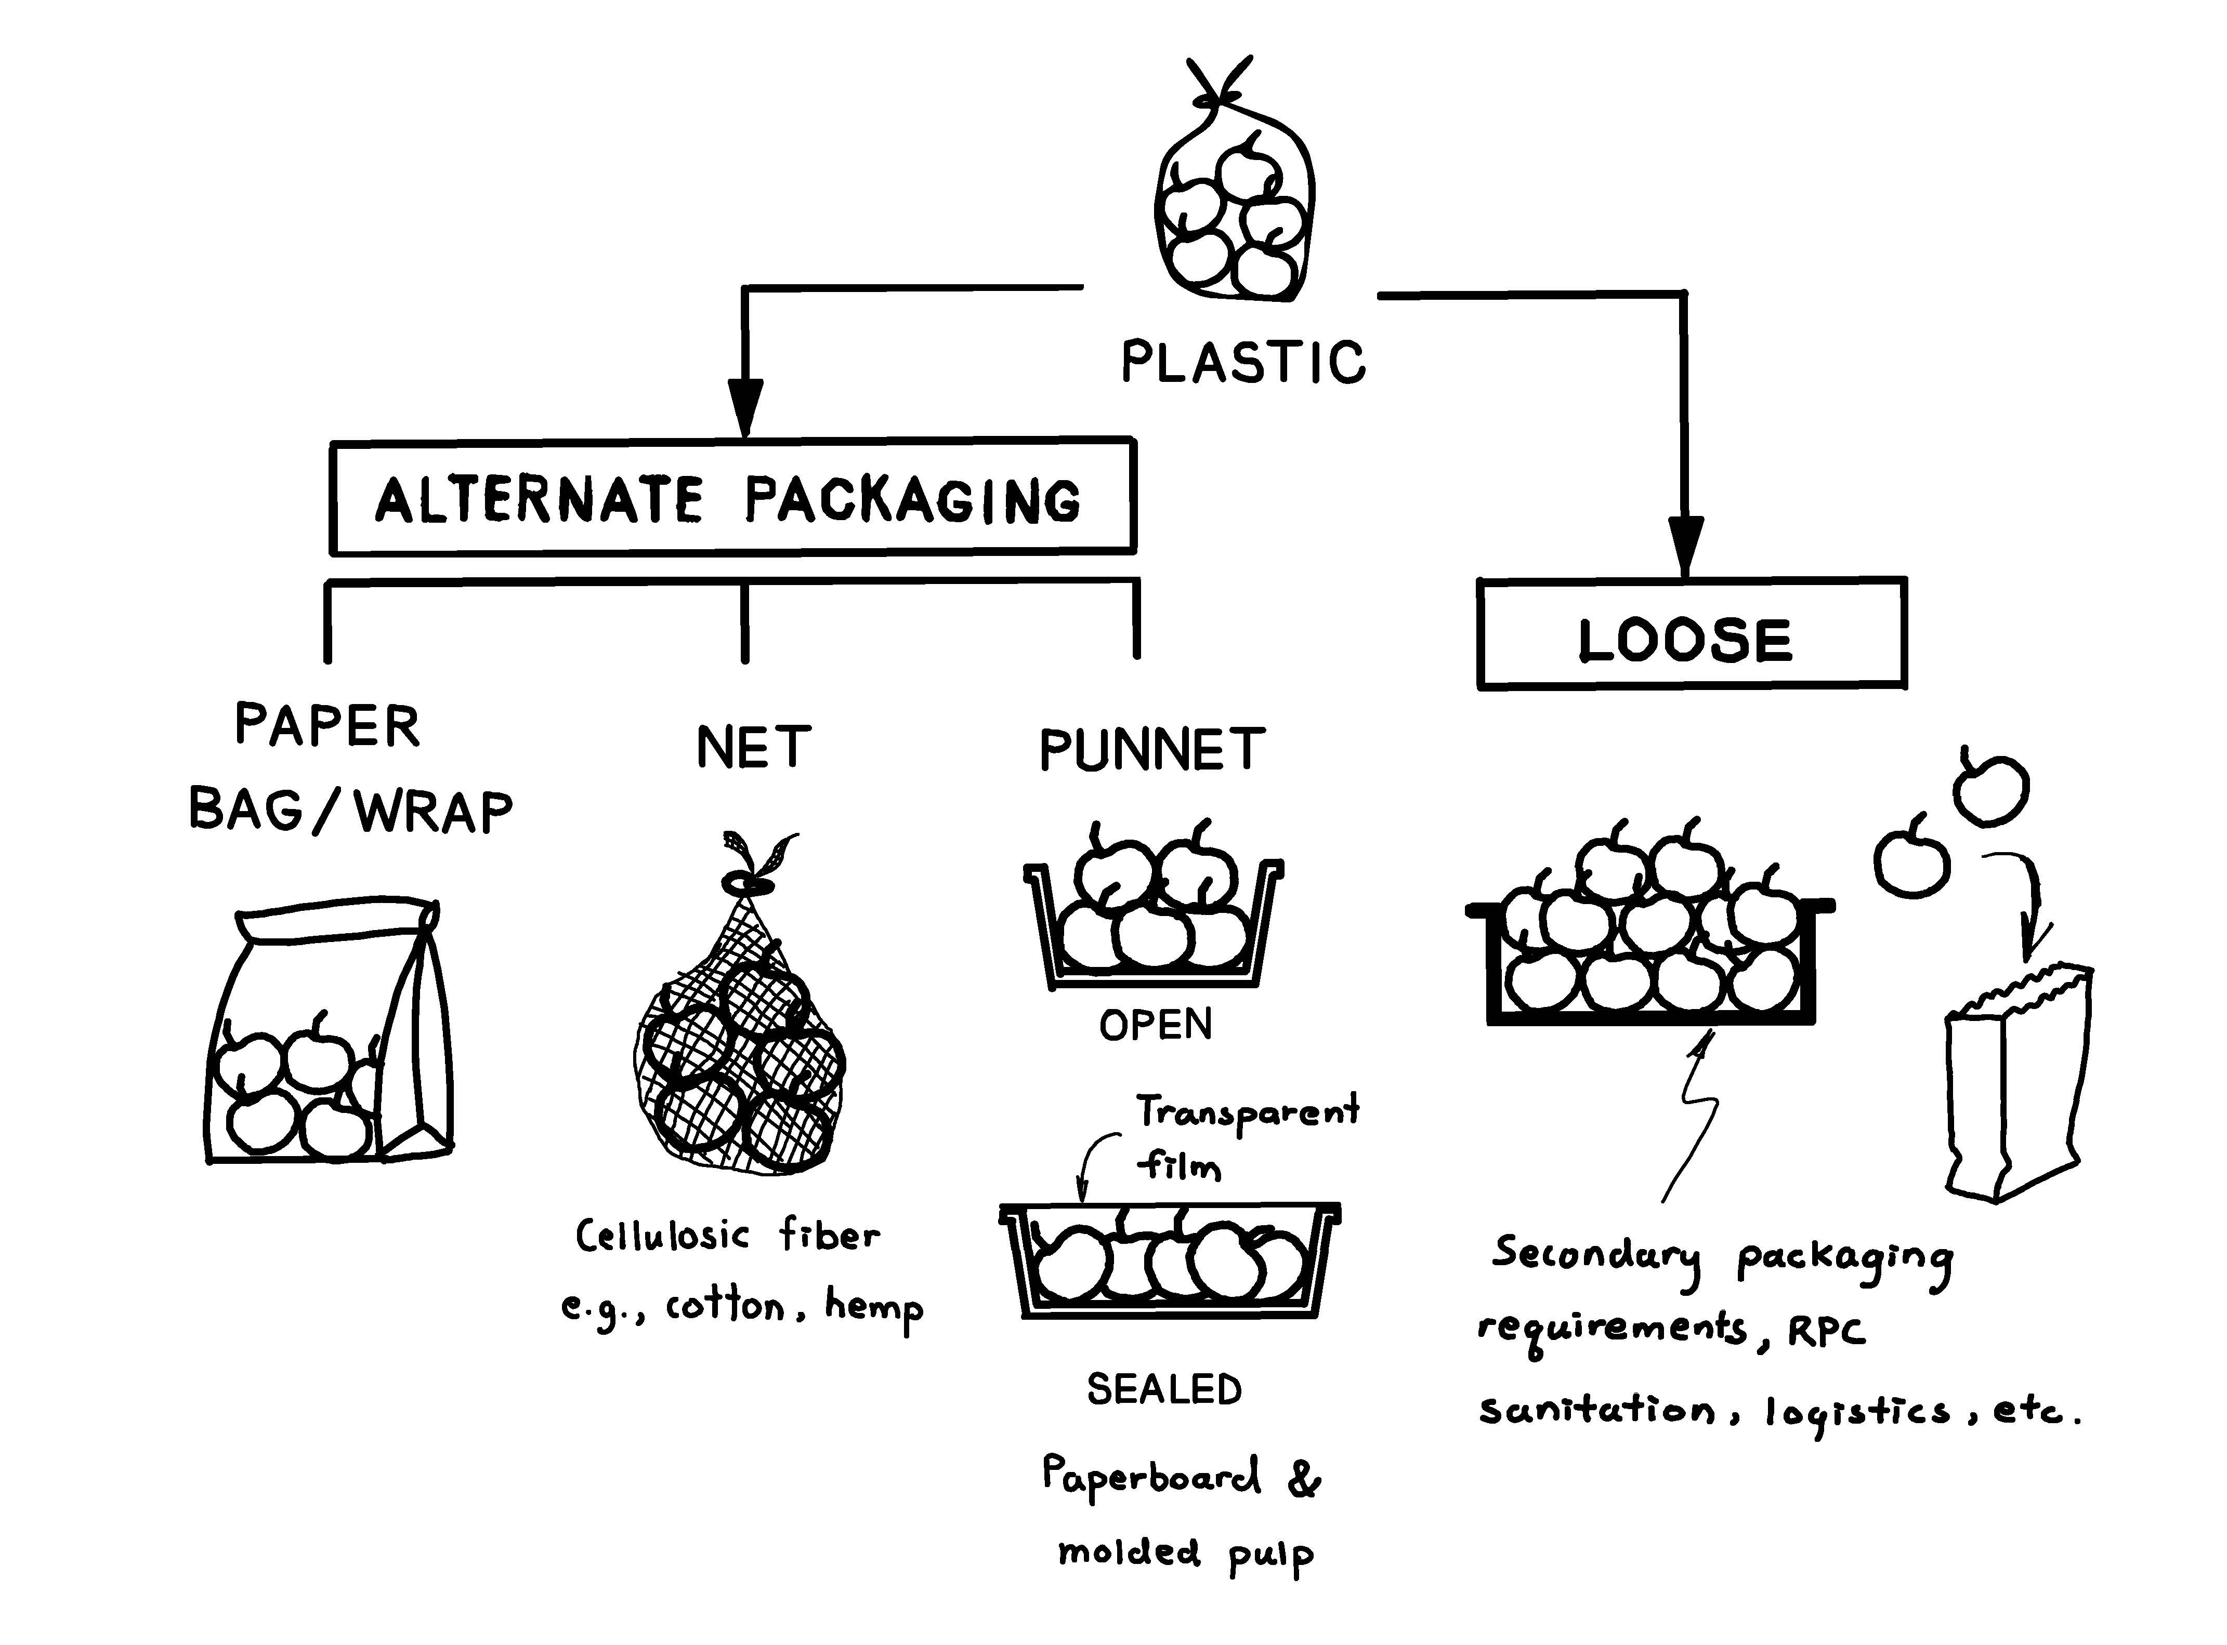
Description of the image above

The project primarily focuses on 6 specific fruits and vegetables across different robustness/ perishability categories, because the biological characteristics of fresh produce, and varietals found within each type, can vary significantly. These characteristics include respiration and/or transpiration rates, sensitivity to ethylene and/or exposure to light, and susceptibility to deterioration due to incorrect handling and/or bacterial load. As a result, their suitability for different packaging materials, or for being distributed and sold in loose form, will vary — particularly when transported over long distances.

In-scope research considerations
Key research considerations within the project's scope include:
- Commercially proven alternatives to plastic packaging that can be managed within recycling or composting streams at scale, for example:
  - Fibre-based packaging
  - Paper/cardboard packaging, including options that are waxed with natural waxes, such as soy or beeswax
  - Packaging innovations that, while not currently available in Canada, have been proven successful elsewhere, such as in Europe
  - Multi-component packaging changes, such as replacing a plastic clamshell with a cardboard carton that includes a transparent viewing window in the lid, provided the components can be easily separated by hand
- Cost of packaging materials
  - Comparative cost of alternative packaging versus current plastic packaging
  - Cost savings from transitioning to loose produce (for example, avoidance of plastic packaging)
- Capital costs
- Operating costs
- Transportation costs
- Transaction costs
- Cost of shrink
- Financial benefits for consumers, from the ability to purchase only the quantity required
- Potential impacts of packaging changes on the importation processes and the availability of fresh produce in the market

Out-of-scope considerations
Key considerations beyond the scope of for this study included:
- Highly perishable fruits and vegetables that formed Category #4 as reported in April 2024:
  - Fruits: berries, fruit salad/mixed fruit
  - Vegetables: broad leaf vegetables, salads
- Non-conventional (biobased, biodegradable or compostable) plastic packaging
  - Therefore, packaging that appears and/or behaves similar to plastic derived from petroleum
- Packaging incompatible with recycling or composting, such as:
  - Wax coated paper or cardboard, unless the wax is natural (for example, soy, beeswax)
  - Laminated or plastic-coated packaging materials
- Economic impact changes in sales velocities resulting from a transition from plastic to alternative packaging or loose formats
- Post-use packaging costs, including the management of post-use packaging materials
- Environmental considerations, such as comparative greenhouse gas (GHG) intensity and emissions associated with packaging materials and end-of-life management of packaging materials

Literature review
The project began with a review of conclusions drawn from the previous study, along with a wide variety of scientific, industry and trade literature, to determine:
- The 6 fruits and vegetables on which the study would focus
- Conclusions drawn from scientific studies into alternative packaging materials for fruits and vegetables
- Evidence of alternative packaging that has been successfully introduced at commercial scale, particularly in the North American and European markets
- Evidence of cost/benefit implications associated with the eliminating plastic packaging and replacing with loose or alternative packaging
- A transition from single-use packaging, such as from cardboard cartons to RPCs, with RPCs potentially replacing both primary and secondary plastic packaging
The review process, along with a determination of how insights drawn from the review would inform the primary research, were guided by informal exploratory discussions conducted with 13 industry experts: 3 growers, 4 packer/shippers, 2 importers/distributors, 2 retailers, and 2 service providers.

Chosen fruits and vegetables
In line with the potential plastic packaging reduction scenarios outlined in the previous study, this study was focused on researching 2 cost implication scenarios associated with transitioning from plastic packaging to loose sale or alternative packaging. As shown in Table 3-1, the changes reflect that hardier items offer more opportunities to viably transition to loose sales or to utilize alternative materials that may perform certain functions less effectively than plastic packaging.
Table 3-1: Comparative opportunities for change by produce category
Produce group | Items chosen for analysis |  | Reduction in plastic
Produce group |  |  | Scenario 1 | Scenario 2
Category 1 | Fruit | Lemons | 50% | 100%
Category 1 | Vegetable | Onions | 50% | 100%
Category 2 | Fruit | Apples | 25% | 60%
Category 2 | Vegetable | Carrots | 25% | 60%
Category 3 | Fruit | Grapes | 25% | 30%
Category 3 | Vegetable | Tomatoes | 25% | 30%
An analysis of domestic production, international trade data, and scientific and industry literature guided the selection of the 6 fruits and vegetables to be studied. To ensure that the potential impact of changes to packaging encompassed both domestic production and import considerations (except for lemons, which are all imported), the selected items comprise a sizable mix of domestically produced and imported produce.
One example of the selection process within each category is the choice between cucumbers and tomatoes, both of which are among the fresh produce categorized in group #3 for vegetables. Tomatoes were chosen over cucumbers for the following reasons:
- The option of not wrapping cucumbers in plastic, instead using an alternative such as an edible coating (for example, Apeel) or not packaged at all, and the pros and cons of each has been well researched.
- Cucumbers differ markedly in the pros and cons of packaging in plastic (for example, English glasshouse versus field grown), due to their comparative robustness and transpiration rates.
- Tomatoes have been less studied regarding the advantages and disadvantages of selling them loose versus packaged.
Table 3-2 below shows the changes in produce sold packaged in plastic versus loose or packaged in alternative materials, along with the corresponding retail sales volumes, the proportion of each that is imported, and the primary source of those imports. The information presented primarily stems from the initial study.
Table 3-2a: Modelled changes in proportion sold prepacked in plastic, proportion imported — Fruits
Fruit | Total annual retail sales volume (tonnes) | Current % of fruit sold in plastic | Volume of total retail sales in plastic (tonnes) | Scenario 1: revised % of fruit sold in plastic | Volume change: additional volume not packaged in plastic | Scenario 2: revised % of fruit sold in plastic | Volume change: additional volume not packaged in plastic | Proportion imported | Primary import sources
Lemons | 77,381 | 61% | 47,203 | 30% | 23,988 | 0% | 47,203 | 100% | USA, South Africa
Apple | 338,290 | 47% | 158,996 | 35% | 40,595 | 19% | 94,721 | 44% | USA
Grapes | 159,219 | 100% | 159,219 | 75% | 39,805 | 70% | 47,766 | Unsure | USA

Table 3-2b: Modelled changes in proportion sold prepacked in plastic, proportion imported — Vegetables
Vegetables | Total annual retail sales volume (tonnes) | Current % of veg sold in plastic | Volume of total retail sales in plastic (tonnes) | Scenario 1: revised % of veg sold in plastic | Volume change: additional volume not packaged in plastic | Scenario 2: revised % of veg sold in plastic | Volume change: additional volume not packaged in plastic | Proportion imported | Primary import sources
Onions | 422,154 | 72% | 303,951 | 36% | 151,975 | 0% | 303,951 | 47% | USA
Carrots | 222,421 | 89% | 197,954 | 67% | 48,933 | 36% | 117,883 | 42% | USA
Tomatoes | 298,181 | 59% | 175,927 | 44% | 44,727 | 41% | 53,673 | 67% | Mexico, USA

Scientific and industry literature

The importance of reducing plastic packaging
Global plastic production and use has grown exponentially since the 1950s. Lightweight, strong and seemingly inexpensive plastics have permeated our lives, our societies and our economies. The rapid growth in plastic production has led to significant negative impacts on the environment, human health and the economy, resulting in costs that are not accounted for in the market price of plastic products.^{note 2}
According to the UN,^{note 3} global consumption of plastic is expected to reach over 500 million tonnes in 2024 alone, with a large share (400 million tonnes) of this used plastic quickly becoming waste. Under a business-as-usual scenario, global plastic waste could almost triple, reaching around 1.2 billion tonnes by 2060. Almost half of all plastic waste is generated in countries belonging to the Organization for Economic Cooperation and Development (OECD).^{note 4} At present, globally, only 9% of plastic waste is recycled, while 22% is mismanaged and the remainder is either landfilled or incinerated.
A growing number of researchers are quantifying the social, economic and environmental costs of plastic pollution. Scientific literature is linking chemicals in plastic and damage to human health at every stage of the plastic life cycle, including workers and 'fence-line' communities living near plastic production and waste disposal sites. In addition to the potential ecosystem impacts, microplastics have been found in the deepest recesses of the ocean, pristine mountain glaciers, breast milk and within human bodies. The evidence of the extent to which the widespread use of plastic is detrimental to human health continues to grow.^{note 5}

Food packaging
Food packaging's increasing reliance on single-use plastic formats, along with the persistence of plastics in the environment, adds to the long-reaching — and as yet poorly characterized — impacts of plastic pollution on ecosystems and human health. A United Nations report has compared the environmental impacts of single-use plastic packaging versus alternative options for supermarket food intended for home consumption.^{note 6} While the findings are extensive, the key findings for this project are clear:
"For foods associated with high environmental impacts in their production (for example, meat), packaging design should prioritize minimization of food waste. For foods with lower environmental burdens in their production, packaging should be minimized and/or eliminated wherever feasible." Therefore, a key message from the study is that wherever the food type allows it, food should be sold unpackaged or in reusable packaging, as this is almost always environmentally preferred to food in single-use packaging.
The report indicates, however, that 'packaging-free' consumer-facing solutions, such as dispensing produce from bulk refillable dispensers or bins, are not necessarily the best environmental solution unless the bulk packaging used in the distribution of the product to the point of sale is considerably more material-efficient than traditional single-use packaging. Returnable packaging and reusable transit packaging (for example, crates) can be a poor option if reverse logistics are inefficient, transport distances for crate collection and redistribution are high, the number of reuses is low, or washing and sanitizing requirements are either high or inefficient.
A 2024 Retail Economics study of the 5 largest retailers operating in Germany, France, Italy, Poland, and Spain estimated that, while single-use plastic is a legacy go-to option for manufacturers and retailers, theoretically, 45% of plastic food packaging could be replaced by either transitioning to alternative packaging or by selling products loose.^{note 7} The study also identified a combination of financial and structural challenges that impact industry's ability to achieve a widespread reduction in plastic packaging within a short to medium timeframe. As identified in studies completed in Canada by VCMI and in the UK by WRAP, many of these challenges relate to consumer purchasing behaviour and expectations.^{note 8} This includes consumer unwillingness to embrace non-transparent packaging or transition away from prepackaged options.

Alternatives to plastic packaging
In a wide-ranging review of recent and emerging food packaging alternatives,^{note 9} experts concluded that: "Currently, packaging alternatives tend to focus on reusing (for example, recycled materials, refillable containers) or discovering (non-plastic) materials that do not result in persistent waste (for example, biodegradable packaging). While some of these alternatives are still under development, there are some already on the market used for packaging a variety of different foods. Like it is for conventional packaging, the type of foods suitable for new packaging alternatives will involve considerations such as properties of food, duration of storage, and economic viability, among others."

Types of alternative packaging
The way the UK Food Standards Agency (FSA) categorizes material or product alternatives to single-use plastics is presented in Figure 3-1.^{note 10}
Figure 3-1: Alternatives to single-use plastics as categorized by the UK Food Standards Agency
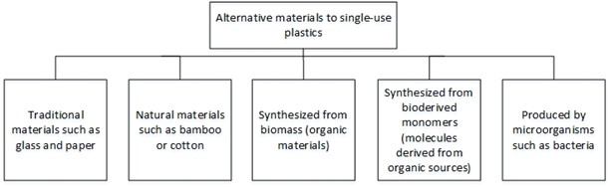
Description of the image above

As identified by the FSA, extensive international efforts are underway to reduce the fresh produce industry's reliance on single-use plastic packaging and improve the sustainability of packaging.^{note 11} In addition, all packaging and merchandizing choices represent a series of trade-offs that must be carefully weighed.^{note 12} Many of the options presented in Figure 3-1 can be ruled out for fresh produce.^{note 13} For example, susceptibility of the packaging to absorb moisture can lead to the premature degradation of the produce item and negatively impact the packaging's functionality, appearance, or tensile strength.^{note 14} This narrows the material choices to:
- Paper, ideally not coated with a resin or other non-organic substance, that would impact its recyclability or compostability potential; and
- Biodegradable and compostable non-plastic materials made from renewable resources like cornstarch or sugarcane, plant fibre or cellulose, which naturally break down over time, into nutrient-rich soil when processed under specific conditions such as those of an industrial compost facility.
As identified by studies completed by Retail Economics,^{note 15} among others, these non-plastic alternatives come with technical and consumer acceptance issues. On the technical side, for example, the composition of biobased materials can vary greatly depending on the source (vegetable or animal-derived). This potential variability from one batch to another makes it difficult to characterize all possible hazards associated with biobased materials. The food safety hazard profiles of some bio-based materials can be similar to the feedstock the materials are derived from; for instance, biobased materials derived from agricultural biomass may have contaminants commonly associated with the latter, such as agrochemical residues.^{note 16}
The following are a few examples of the wide range of alternatives to plastic fresh produce packaging that have been developed and tested worldwide and introduced commercially with varying degrees of success.
- Evesham Specialist Packaging Ltd. has developed a certified compostable sugarcane-based packaging. While it is more expensive to produce, and is a much slower production process compared to plastic, there are some environmental benefits since it is made from a renewable feedstock, and can break down in the conditions of an industrial composing facility. The process has been patented in the UK, Europe and Canada.^{note 17}
- Multivac PaperBoard offers various solutions for the production of packaging based on paper fibres. The company says that it is possible to pack soft fruit, mushrooms, grapes or tomatoes in cardboard trays with a plastic top seal.^{note 18}
- Smurfit Kappa have produced paper-based punnets that are recyclable and made from resource.^{note 19}
- Amcor's AmFiber's paper-based packaging is suitable for a variety of foods and beverages.^{note 20}
- Graphic Packaging and ProPrint are among the less well-known packaging companies who have produced comparative case studies illustrating how their paper packaging purportedly compares to plastic for its functionality capability and consumer experience perspectives.^{note 21}
- Costa transitioned to paper packaging for premium grapes sold in Coles Australia.^{note 22} This initiative was led by Navi Co Global, a company which has assisted multiple vendors to make similar transitions in other fruits and vegetables.
- Detpak's^{note 23} packaging manufactured from natural fibres including sugar cane is used on a commercial scale for a range of food products, including fresh produce.
As illustrated by the above examples, a wide range of paperboard packaging has been developed using renewable plant-based fibre. These can range from open cartons, baskets and nested trays with a plastic top seal. A challenge with a porous material like paper is the barrier, although this can be overcome in a variety of ways to extend shelf life. One study has shown that these offer at least equivalent shelf life for tomatoes, and are superior to plastic in terms of reducing mould growth.^{note 24}
'Flow wrap' style paper has also been developed, made from paper with a bamboo fibre/paper viewing mesh. This has had some success with fruit and vegetable lines in retailers, although the viewing 'window' can damage apples and is necessarily small to maintain the integrity of the packaging. This can lead to a heavily printed front pack to show the product. Again, trials of this material led to a significant drop in sales.

Key factors influencing the speed of transition
The most common use of non-plastic packaging at present is typically for speciality lines, where product differentiation can provide a price premium and sustainable packaging assists in the product's point of differentiation.^{note 25}
In any transition to a non-plastic alternative, particularly for use in commodity items, the following factors should be considered:^{note 26}
- Price and cost considerations — while sustainable packaging may have a perception of being more expensive, it is crucial to take a long-term view. Assess the total cost, considering factors like material savings, operational and labour efficiencies, and potential marketing advantages.
- Materials and design — re-evaluating current packaging materials is a crucial step. Consider alternatives such as recycled or recyclable materials, or biobased materials. Additionally, optimizing packaging design to reduce material usage and waste can have a significant impact on sustainability.
- Tray sealing can integrate flexible, recyclable film seals, recyclable plastic lidding, and fibrous paper-based materials. It can thereby reduce packaging materials' volume by 15 to 30% compared to more traditional packaging, such as clamshell or PVC overwrap.
- Challenges and solutions — shifting to sustainable packaging may involve challenges such as supply chain complexities, cost considerations or ensuring compatibility with existing manufacturing processes. To overcome these challenges, it is crucial to take a phased approach. Start with pilot projects to test and refine sustainable packaging solutions before implementing them on a larger scale. Engage employees and stakeholders, fostering a culture of sustainability within the organization.
- Trialling of paper and card seal packaging by British Apples and Pears found that consumers were resistant to change, with a significant drop in sales often leading to a return to plastic. The report noted that this consumer resistance resulted in part from a 5 pence to 15 pence per pack increase in price.^{note 27}
The key reason for the challenges and reduction in sales noted above can be attributed to reduced visibility of the product. Even retailers with a strong reputation for customer satisfaction and quality are finding that customers, accustomed to seeing the whole product, do not respond well to opaque card and paper packaging. There is also the question of the significant increase in cost related to alternative formats. All alternative formats are currently more expensive than pre-printed flow wrap. With both higher material costs and the requirement for new machinery, the true costs of transitioning to alternative packaging can far exceed the cost of the packaging itself. Notwithstanding machinery costs and redundancy of existing equipment, some alternative solutions also require more labour on the production line, which, along with a slower production rate, increases overall production costs.
Commitments to change being enacted by North American businesses could, however, accelerate the speed at which packaging innovations are commercialized. They could also lessen consumers' resistance to alternative packaging. Such commitments include Costco, who are actively working with vendors to introduce paper and fibre packaging for fruits and vegetables. Other retailers, such as Loblaw, are driving widespread changes to packaging design by causing suppliers to incorporate the Golden Design rules throughout their packaging decision-making processes.^{note 28} These changes can include the replacement of plastic, in full or in part, with paper or fibre packaging.
The speed of commercialization is also anticipated to increase as sustainable packaging becomes increasingly more cost-effective due to significant investments in research and development, stricter environmental policies and regulations, and growing consumer awareness driving its advancement. An example of the major public and private investments being made in sustainable packaging research development is the establishment of the Sustainable Packaging Innovation Lab at Clemson University, South Carolina.

Transition to loose
Before the advent of supermarkets (multiple retailers), selling loose was the norm on market stalls. Today many retailers are allocating more space to loose sales, driven by regulatory pressures to move away from single-use plastic, and other considerations. Retailers have a wide range of options for merchandising loose products; however, regardless of the method they choose, value chain cooperation is essential to avoid unnecessary costs.^{note 29} Critical issues in the transition to loose sales thereby include:
- How the final product is merchandized to consumers and their acceptance of loose versus packaged options (for example, customer satisfaction with product presentation and cost differences)
- How the product is handled throughout the value chain, from grower to store, in order to avoid re-packing and other additional costs
- Safety and damage considerations for the product
Cross market comparisons in the EU^{note 30} suggest that France has the lowest proportion of food and drink items found in supermarkets that are packaged in plastic (59%), while the UK has the highest proportion (70%). The same report indicates the majority of European food and drink businesses are actively working toward reducing their reliance on plastic packaging. For comparative purposes in fresh produce only: in the UK, approximately 80% of fruits and vegetables are sold packaged in plastic. In Canada, approximately 45% of fresh produce is sold packaged in plastic.^{note 31} This places Canada closer in line with mainland Europe, where approximately 50% of fresh produce is sold packaged in plastic.
A study of historical loose product trials by retailers in the UK^{note 32} has shown mixed results:
- Unsuccessful: In-store spoilage rates doubled to approximately 6%, caused by "acceleration of the ripening process" produce becoming damaged and not subsequently purchased, and the practical difficulties of keeping track of stock rotation. Many consumers "preferred to buy packaged produce" for reasons of convenience and hygiene (Asda; self-reported).
- Successful: The number of stores selling loose produce increased from 63 in 2019 to 332 in 2020. Additionally, a customer survey conducted as part of the trial revealed that 75% of customers preferred to buy fresh produce loose (Morrisons; self-reported).
- Mixed: The trial successfully reduced the amount of plastic waste generated and overall greenhouse gas emissions by providing a wide range of fruits and vegetables unpackaged. However, consumers reported that there was a loss of quality of some of the unpackaged products (thereby implying a possible increase of in-home waste), and that they would return to the packaged version if quality was compromised (Waitrose; self-reported).
In the UK, WRAP has conducted research examining the relationship between plastic packaging and uncut fresh produce. The research highlighted a significant potential to reduce food waste by enabling consumers to purchase only what they need, while also reducing plastic packaging by increasing the amount of fresh produce items sold loose.^{note 33} WRAP acknowledged that value chains have been optimized for selling fresh produce in packaging and consumers have become accustomed to buying it that way. Therefore, solutions need to be found to reconfigure value chains and store operations, and to make it easy and convenient for people to buy loose produce.
The WRAP report outlines a pathway for retailers to follow as they move toward selling more loose fresh produce. It includes a set of principles, key targets and timelines to guide this shift.
A report for British Apples and Pears^{note 34} identified several barriers to selling loose including:
- Consumer resistance for many reasons, including a perceived lack of quality, concerns about hygiene, confusion over the cost of the items, the cost compared to prepackaged options, and the convenience of picking up packaged items.
- Retail specifications tend to dictate that loose fruit is at the larger end of the size range, with 68 mm to 80 mm diameter fruit found in loose presentation. Many consumers find this size too large. To address this, smaller fruit would also need to be offered in loose formats to ensure growers can still market the full range of their crop.
- More store staff are required to ensure the quality appearance of the fixtures. There is a reluctance with most retailers to invest at this level, and food waste at store level could be significant due to damage.
- More production lines would be needed to handle loose fruit, and those that reduce the need for fruit handlers are a considerable expense. The packing of loose is slower, and this will lead to more production lines to maintain volume, which again negatively affects operational balance sheets.
Though the concept of purchasing loose fruits and vegetables appeals to the majority of consumers, research conducted in Germany,^{note 35} the US^{note 36} and Canada^{note 37} corroborated and expanded upon a number of the UK findings presented above. They include factors that impact consumers' decision to purchase prepackaged instead of loose. They include:
- Loose fruits and vegetables can cost consumers an average of 32% more than purchasing the same weight packaged.
- The purchasing of loose produce represents a more intentional and time-consuming process than the convenience of choosing packaged.
- Inefficiencies associated with the in-store handling, management and sale of loose versus prepackaged fresh produce heavily influences businesses' sizing, grading and pricing decisions.
Consumer acceptance of loose fruits and vegetables will be critical for any transition away from plastic packaging. The main reason why consumers purchase fruit in a package is the convenience it offers during the selection process.^{note 38} This convenience in turn leads to in-store merchandizing, enabling retailers to create a sense of 'theatre' through promotions and other creative displays. Typically, loose fruits and vegetables can be displayed using 3 broad methods, each with multiple variations: (1) market stall approach, (2) vessels including boxes and trays or similar, and (3) plastic crates — with the first 2 being 'plastic free'. There are numerous ways each method can be carried out.^{note 39note 40}

Reusable plastic crates (RPCs)
RPCs provide one possible solution to some of the challenges associated with the logistics and shrink associated with the sale of loose fruits and vegetables. In the UK, RPCs are widely used for the transport and distribution of both loose and packaged produce, and food in general.
In the Netherlands, 80% of all fresh produce is transported in reusable crates.^{note 41} RPCs are vessels or containers used to package and safely transport goods, replacing the traditional roles of corrugated boxes and wood crates that dominated value chains for over a century. Retailers can also directly merchandize products using RPCs. Plastic crates exploded in popularity in 1991, when Germany made value chain sustainability history by requiring businesses to separate and recycle 80 to 90% of traditional packaging materials to keep them out of landfills.
A detailed life-cycle analysis concluded that the food industry should adopt RPC use because of their higher economic, environmental performance and circularity.^{note 42} Key benefits include reduced distribution, labour and transactions costs, alongside fewer health and safety incidents, especially for retailers utilizing one-touch merchandizing practices. (See Annex A for an extended discussion of opportunities and challenges pertaining to RPCs.)
One study^{note 43} using cauliflowers showed a higher risk of cross-contamination for RPCs compared to cardboard, despite their better environmental impact compared to single-use containers such as cardboard and wooden boxes. To exploit the potential environmental benefits of RPCs while ensuring food safety, it is necessary to guarantee the hygiene of this type of container. The execution and enforcement of best management practices along the entire value chain are therefore critical.^{note 44}
There are many manufacturers of RPCs. According to a leading global supplier,^{note 45} RPCs can deliver a whole value chain solution, from delivering clean RPCs to producers, to collecting used RPCs from retailers. This can include strictly enforced standards of global hygiene and sanitation in wash facilities. According to IFCO Ltd, such solutions can provide:
- RPCs in a variety of sizes suitable for fruits and vegetables
- Better protection reducing damage by over 96%
- Up to 27% cost saving compared to single-use packaging
- Retail ready with no unpacking or re-packing required
- Up to 60% less carbon dioxide, and 86% less solid waste
Based on VCMI's assessment of the above literature review and the data accumulated from store audits, 4 of the 6 products studied — lemons, apples, onions and carrots — have the potential to transition to a higher proportion of sales in a loose format. Where circumstances allow, RPCs could assist with this transition by minimizing handling and reducing spoilage throughout the value chain, all the way to the point of purchase by consumers. This process, referred to as "one-touch," ensures that products remain untouched from the moment they are placed in the RPC until they are purchased by consumers, enhancing both efficiency and product integrity.^{note 46}

Implications for the primary research
As described in the following sections, the review identified several key barriers to the industry's transition to non-plastic alternatives, including packaging materials or sale in loose format. These barriers primarily stem from the economic implications of changes such as costs associated with the adoption of new business models, rather than technical implications such as reduced shelf life and food safety concerns. The main barriers are as follows:
- Capital expenditure and long-term strategic investments
- Ongoing raw material and operational costs
- Product integrity and quality
- Consumer acceptance and marketing
- Food safety and contamination concerns
Depending on the nature of the changes required to transition to alternative packaging or sale in loose format, the one-time capital expenditure (capex) and ongoing enterprise-level costs of such a transition can range from minimal amounts to millions of dollars. In summary, therefore, the key areas for primary research to investigate the implications of this transition to alternative packaging or loose format include:
- Could the need to establish dedicated production lines for a specific market, particularly if it represents a small proportion of overall sales, cause suppliers to exit a market?
- What are the implications of capital expenditures and subsequent changes in operational and transactional costs on the final prices paid by consumers?
- What factors primarily determine the economic viability of transitioning to alternative packaging or the sale of loose versus in prepackaged forms?
- To what extent do geographic factors influence the feasibility of such transitions?
- Will a reduction in costs necessarily translate into lower prices being paid by consumers?
- Could transitioning to RPCs and paying fewer/no EPR fees/no plastic registry reporting costs reduce individual businesses' costs of operation, including whether they are sufficient to ensure that prices paid by consumers do not increase?
- Is consumer resistance to change as significant a barrier as it has been reported to be in other jurisdictions?

Primary research
This section describes the primary research conducted following completion of the literature review and initial exploratory discussions with 13 fresh produce experts from operations across North America, Europe and other international markets.

Retail audits
The primary research began with the completion of retail audits in the UK and Canada to identify instances of where alternative packaging has been introduced on a commercial scale, particularly in relation to the 6 fruits and vegetables being studied. The topline results of these retail audits are summarized below.

UK retail audits
In the UK, with the exception of grapes, all of the visited retailers offered the other 5 items in both loose and prepackaged formats. While alternative packaging has been trialled (for example, Marks & Spencer [M&S] piloted the sale of apples packed in cardboard boxes), most of these initiatives appear to have been commercially unsuccessful and were subsequently withdrawn. As identified in the reviewed literature, the reasons for this likely include:
- A drop in sales, because consumers cannot see the product
- Prices having increased due to higher packaging material, operational and transactional costs, resulting in consumers purchasing the lesser expensive option
An example of items that have successfully transitioned to alternative packaging include premium items, where consumers' purchasing decisions are less focused on price and more on attributes such as visual appeal and eating experience, reducing concerns about the higher cost associated with these items. An example of such an item is shown below.
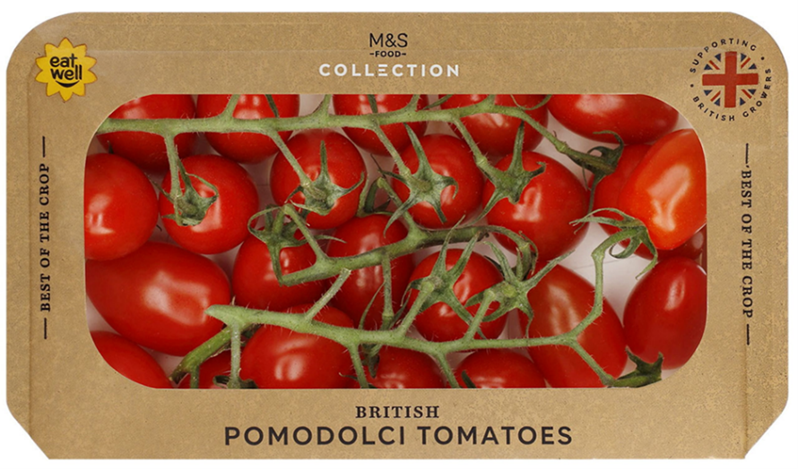
The review of fresh produce packaging and merchandizing arrangements in the UK, and Europe more broadly, identified a trend toward the sale of loose produce and the use of RPCs. The shift is attributed to factors such as reduced distribution, labour and transactions costs, along with fewer health and safety incidents — especially for retailers that have adopted one-touch merchandizing practices.
It should however be noted that:
- A higher proportion of fresh produce is currently sold in single-use plastic packaging within the UK compared to Canada, therefore the UK opportunity to readily transition to loose is greater.
- The comparative volume of specific fruits and vegetables sold loose versus prepackaged in the UK is unknown.
- The majority of fresh fruits and vegetables sold in the UK are shipped to retail stores and displayed in RPCs, regardless of whether they are offered for purchase in loose or prepackaged format.
An audit of major UK grocery stores was conducted to assess the different forms of packaging used for the 6 fruits and vegetables identified in the initial analysis. The findings are summarized in Table 4-1.
Table 4-1: Summary of fresh fruit and vegetable merchandizing formats found in 4 UK retail stores
 | Morrisons | Sainsbury's | Waitrose | M&S
Lemons | Loose  Plastic net bag | Loose  Plastic net bag | Loose  Plastic net bag | Loose  Plastic net bag  Plastic bag, with netted front for viewing
Apples | Loose  Plastic bag  Cardboard tray, wrapped in plastic | Loose  Plastic bag | Loose  Plastic bag | Loose  Plastic bag
Grapes | Cardboard tray, wrapped in plastic | Plastic clamshell | Plastic bag  Plastic clamshell | Plastic clamshell
Onions | Loose  Plastic net bag  Plastic bag | Loose  Plastic net bag  Paper bag, no viewing window | Loose  Plastic net bag | Loose  Plastic bag
Carrots | Plastic bag | Loose  Plastic bag | Loose  Plastic bag | Loose  Plastic bag  Cardboard tray, wrapped in plastic
Tomatoes | Loose  Plastic  Cardboard tray, wrapped in plastic | Loose  Plastic  Cardboard tray, wrapped in plastic | Loose  Plastic  Cardboard tray, wrapped in plastic | Loose  Plastic  Cardboard tray, with transparent plastic top film  Cardboard box, with open viewing window

Canadian retail audits
As in the UK, with the exception of grapes, all of the visited Canadian retailers offered the studied items in both loose and prepacked formats. While alternative packaging has been trialled across various products and retail environments, its widespread commercial adoption has proven challenging. A key reason for this is consumer behaviour, resulting in increased damage, losses and transaction costs. As identified in the literature, consumers' inability to see the product from all angles in alternative packaging has led to a drop in sales, with some consumers breaking packages open to inspect the contents. The contents of these opened packages typically go to waste.
An example of an item found to have adopted alternative packaging is presented below.
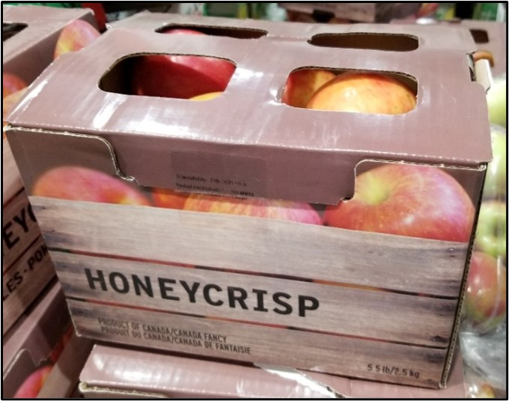
Findings from the audits completed in major Canadian grocery stores, to assess the different forms of packaging of the same 6 fruits and vegetables (as per the UK audits), are summarized in Table 4-2.
Table 4-2: Summary of fresh fruit and vegetable merchandizing formats found in 6 Canadian retail stores
 | Longo's | Fortinos | Sobey's | Whole Foods | Metro | Farm Boy
Lemons | Loose  Plastic net bag | Loose  Plastic net bag | Loose  Plastic net bag | Loose  Plastic net bag | Loose  Plastic net bag | Loose  Plastic net bag
Apples | Loose  Plastic bag | Loose  Plastic bag  Open box | Loose  Plastic bag | Loose  Plastic bag | Loose  Plastic bag | Loose  Plastic bag  Open box
Grapes | Plastic bag | Plastic bag | Plastic bag | Plastic bag | Plastic bag | Plastic bag
Onions | Loose  Plastic net bag | Loose  Plastic net bag  Cardboard box with plastic wrap | Loose  Plastic net bag  Shallots in cardboard box with plastic wrap | Loose  Plastic net bag | Loose  Plastic net bag | Loose  Plastic net bag  Cardboard tray with plastic wrap
Carrots | Loose  Plastic bag | Loose  Plastic bag | Loose  Plastic bag | Loose  Plastic bag | Loose  Plastic bag | Loose  Plastic bag  Cardboard box with plastic wrap
Tomatoes | Loose  Plastic | Loose  Plastic  Box with plastic wrap  Cardboard tray with plastic wrap | Loose  Plastic  Box with plastic wrap | Loose  Plastic | Loose  Plastic | Loose  Plastic

Average price of loose versus packaged
As summarized in the literature review presented in Section 3.2.4, for numerous reasons relating to fixed and variable costs incurred by businesses operating along the value chain, by weight (price/kg), consumers typically pay 32% more for loose than prepackaged fresh produce.
Using apples as a notional proxy to establish a directional comparison of loose versus packaged in the UK and Canada (because the German study mentioned earlier identified that non-organic apple pricing differentials matched the overall average established across multiple produce items, that is, 32%), the store audits included noting the prices of apples sold in each format. The audits identified that, in the UK and Canada, compared to the prices of packed non-organic apples, the same volume of apples purchased loose can cost consumers 24% and 39% (respectively) more than when purchasing packed apples. As per the German study, this comparison ignored size and grading/quality considerations.

RPCs – Reusable plastic crates
A key difference between Canadian and UK grocery retail stores is the UK's adoption of one-touch merchandizing practices for both loose and prepackaged fresh produce. In contrast, the vast majority of loose and prepackaged fresh produce sold in Canadian stores are manually placed as individual units on retail shelves. This increases the cost of labour, the risk of produce damage due to additional handling, as well as making displays more susceptible to spillage. These differences in operational costs, due to the widespread use of RPCs having increased grocery store efficiencies, could partly explain the differences between UK and Canadian (versus German) average comparative price of loose versus packaged apples. Additionally, the more that loose produce is handled by infected staff or spills onto the floor at any point along the chain, the greater the potential for microbial contamination to occur.
Discussions with packers, shippers, distributors, retailers and RPC suppliers identified that the Canadian fresh produce industry is steadily adopting RPCs as standard practice. This adoption of RPCs has occurred much slower than in the UK and mainland Europe. Evidence gathered during the review process, along with precompetitive initiatives such as the RPC Taskforce recently established by the Canadian Produce Marketing Association, suggest that the adoption of RPCs across the Canadian and North American fresh produce industry could markedly increase in coming years.
Given that a significant proportion of the fresh produce consumed in Canada is imported, the actual rate of RPCs' adoption will be impacted by factors that are not applicable to domestic supply chains. These include the effect of bi-lateral trading relationships and practices, and bi-lateral phytosanitary rules and regulations that extend beyond Codex Alimentarius^{note 47} agreements, which form the foundation of global food safety and quality related trade practices. The structure of individual supply chains (for example, closed loop systems governed by a multinational corporation involving a small number of large businesses, versus hub and spoke transactional systems where produce flows through multiple smaller businesses until it reaches the final point of sale to consumers) will also impact the rate of adoption.

Modelling cost implications of change
Presented below in Figure 4-1 is a schematic of the produce value chain, from the packaging of the product through to its disposal (if unsold). All of these steps need to be considered when determining the cost implications of changes made to primary packaging. This includes transitioning from single-use packaging and/or carton to RPCs, and subsequent changes to store merchandizing arrangements.
Figure 4-1: Value chain map of process step, costs, performance metric
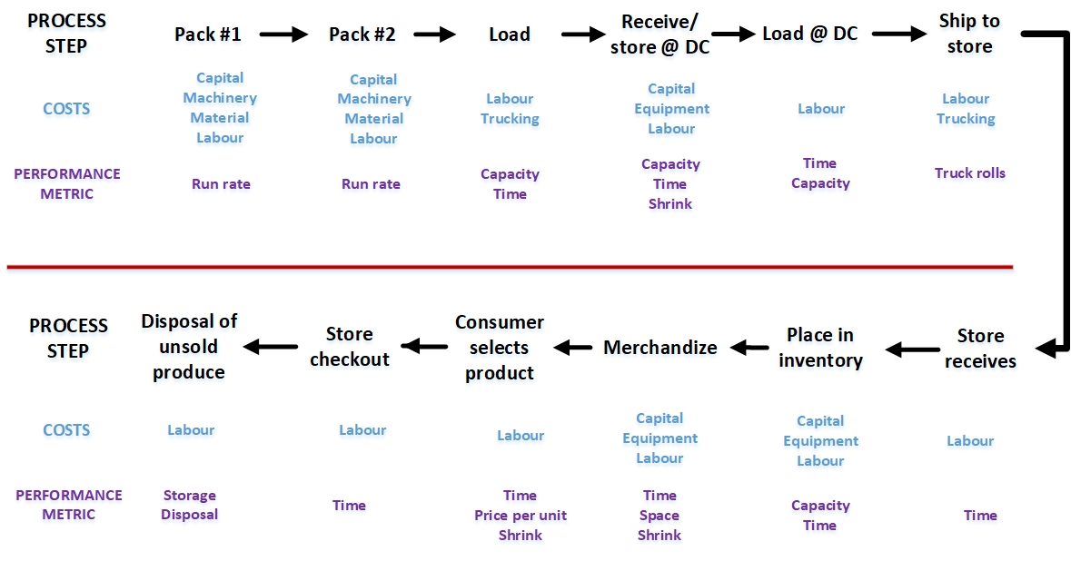
Description of the image above
As can be seen, the impact of these changes on operations and processes along the entire value chain, from the initial packing of fresh produce to their sale in retail stores, was encompassed in the research and analysis. These findings, combined with insights that emerged from the literature review and retail audits, informed the development of questions posed to produce and packaging industry experts and the design of supporting materials used to capture their responses.

Summarized findings from industry consultations
The data required to complete the cost implication analysis (see Section 4.4) was captured through semi-structured interviews conducted with 29 industry experts from businesses operating in Canada, the US, Mexico and elsewhere, internationally — including Europe and Australia. Discussions were also conducted with 5 individuals from within advocacy groups. The discussion guide and matrices were developed to ensure the gathering of the common standardized data required to evaluate the cost implications of transitioning from plastic to alternative packaging materials or selling produce in loose formats. These tools are detailed in Appendices B and C.

Motivation to change
A key question posed to all respondents explored whether they felt motivated to transition away from plastic packaging. The majority of respondents (~90%) believe that there is too much plastic in the fresh produce marketplace and acknowledged a motivation to transition to alternative packaging. However, this motivation was tempered by financial concerns and consumer resistance to acceptance of non-transparent materials. As one produce industry veteran explained, "The introduction of plastic packaging was driven by cost; it came in at over 70% cheaper than paper packaging."
Respondents' views regarding the motivation to transition to the sale of loose produce, potentially in tandem with a transition to RPCs, were considerably different. Less than 25% of respondents expressed motivation to transition to the sale of loose, and approximately the same percentage (25%) of respondents actively supported a transition to RPCs. Additionally, all respondents view loose produce and RPCs as essentially being 2 separate topics.

Alternative packaging
Respondents stated that, while the actual cost of packaging can differ quite markedly (for example, bags versus clamshell punnets), packaging typically accounts for between 5 and 7% of the retail price of fresh produce. A number of respondents also said that a price increase of more than 6% measurably reduces sales.
Key reasons for respondents' lacking a strong motivation to transition to alternative packaging primarily revolved around the lack of a proven business case and/or its impact on market demand, particularly in relation to commodity versus premium items. This sentiment was shared by individuals whose businesses transitioned to alternative packaging and were currently serving North American customers.
Respondents commented that even when their transition to alternative packaging had not led to an increase in retail prices, they had invariably experienced a significant drop in sales. This drop in sales remained unchanged and reflects findings that emerged from the literature review regarding customers' displeasure with alternative packaging. A grower/packer respondent provided a specific example of where after having reverted to packing the same item in plastic, sold at the same price as previously, sales returned to their previous levels. As identified in the literature review, consumers' acceptance of non-transparent alternative packaging is not, therefore, tied to price differentials alone.
Those situations where respondents stated that a measurable increase in sales had followed products' transition to alternative packaging materials shared 3 common factors. Firstly, the shape and general appearance of the packaging had not markedly changed from that which it replaced (for example, having replaced a plastic pouch bag with a paper pouch bag). Secondly, it enhanced the products' overall value proposition (for example, carries a consumer-targeted message that emphasizes the products' credence characteristics). Thirdly, it allows consumers to inspect a good representative sample of the produce prior to purchase (for example, through a viewing window). In most cases, where examples involved premium items, the transition typically resulted in price increases of no more than 10%.
Respondents indicated that retailers are tightening their specifications due to the inability to adequately and easily inspect the product within the packaging as well as they can with transparent plastic. This ensures that produce packaged in alternative materials is of a higher quality than that allowed to be packaged in transparent plastic. Higher grade-out rates, which would result in a smaller proportion of the overall crop reaching markets, could drive up the price of goods. This is, therefore, another potential cost implication associated with a transition to alternative packaging.
Over 90% of respondents cited that a lack of unbiased insights and actionable expert advice limited their motivation to transition to alternative packaging. The lack of packaging equipment suited to handling alternative packaging is also an impediment to change, because it results in the packing of alternative materials being noticeably more labour intensive than the packaging of plastic. A lack of packaging equipment suited to handling alternative materials is in part due to expectations within the packaging and packaging equipment industry that plastic packaging will continue to persist once current challenges hindering the circular plastic economy have been addressed. As well, considerable capital investment is required to design and manufacture packaging equipment. The production of such equipment will not therefore occur without the produce industry having expressed a long-term commitment to transition to alternative packaging.
Another commonly cited key reason for why more change has not occurred relates to a perceived lack of retailers' leadership in driving innovation. This view was countered by a number of respondents, who voiced that they are working with retailers to pilot alternative packaging "under the radar screen." The purpose of this approach is to test consumers' acceptance of alternative packaging and its functional performance without negatively impacting consumers' perceptions of the retailer(s) and their suppliers.
Three highly experienced retail representatives directly spoke to a perceived lack of leadership within the retail sector, stating that while retailers are not necessarily uninterested in change, stakeholder relationships and the need to manage public perception often take precedence over operational decisions. As well, in a highly competitive marketplace, retailers are cautious about implementing sweeping changes that could put them at a competitive disadvantage. They stated that widespread change was, at least to some extent, dependent on the existence of pre-competitive motivation to drive the change. They suggested that this could include the introduction of carefully designed packaging legislation.

Transition to loose
Key reasons for respondents' lack of motivation regarding a transition to sale in loose format, potentially in conjunction with a transition to RPCs, primarily revolved once again around the lack of a convincing business case. Negative perceptions regarding transitioning to a loose format were more related to items whose quality more easily depreciates when handled or is exposed to the environment, leading to increased shrink and higher operational and labour costs.
As well, retail respondents said, 80 to 85% of consumers will choose packaged produce over loose. This they said, and evidenced in the literature review, relates to the convenience of buying packaged, along with price and health/phytosanitary concerns. All of the retail respondents also stated that those consumers who prefer packaged over loose often represent considerably more than 80 to 85% of total fresh produce sales. This included a veteran retail respondent who stated, "Selling loose is easier for us, though most consumers don't want to buy loose. They may say they do, though in reality they don't." This perspective came from a respondent who supports the use of RPCs due to their suitability for automated handling at distribution centres and that they provide a one-touch merchandising option which reduces the need for handling and repackaging at store level. Again, this aligns with insights that emerged from the literature review.
Conceptually, the selling of loose produce typically involves handling fewer bulk items, rather than managing individual SKUs of different sizes or weights. However, depending on the product, loose formats can still present challenges related to shrink and variable presentation at retail.
For the same reasons as cited below regarding a transition to RPCs, respondents stated that any reduction in packaging costs due to having transitioned to packaging in 'bulk' for sale of loose produce is unlikely to translate in prices charged to consumers. They also stated that domestic producers need to sell their entire crop, and that the consistent high-quality produce of a size suited to selling loose represents only a proportion of total production. Therefore, the volume of domestic production suitable for selling loose is more limited than many would expect.
Unless product quality and grading are strictly managed, a combination of downstream inefficiencies and high shrink at the store level (compared to that experienced with packaged produce) exacerbates the factors that lead to loose produce being merchandized at higher prices than packaged. This is particularly the case in produce items that are susceptible to damage and loss when handled, such as grapes. See Section 4.3.2 for a summary of fruits' and vegetables' comparative suitability for selling in loose.

Transition to RPCs
Aversion to the adopting of RPCs was most common among respondents whose businesses relied heavily on sourcing or selling through the open market (for example, Toronto Food Terminal), or who were dissatisfied with their prior experience of RPCs. Respondents who had transitioned to RPCs, or had worked with enterprises that adopted or considered transitioning to RPCs, stated that a reduction in costs from moving away from single-use primary and secondary packaging will not necessarily result in lower consumer prices. The main reasons for this include enterprises taking the opportunity to retain the increased margins for their own commercial benefit, particularly given inflationary cost pressures impacting the industry in recent years. Any transition to RPCs often entails added costs, especially in the short to medium term, which further limits the potential for consumer price reductions.
Respondents' views on the benefits and limitations or concerns associated with the utilization of RPCs versus single-use packaging closely aligned with findings from the literature review. Over half of the respondents stated that retailers stand to benefit the most from the adoption of RPCs, citing their potential to reduce in-store labour requirements by approximately 50%. Respondents also indicated the sturdiness and ease of stacking offered by RPCs, which contributes to measurable less shrink, especially in distribution centres (DCs) and during the building and distribution of mixed pallets to stores. RPCs also allow for improved ventilation and more effective cold chain management, and they are subject to lower EPR fees.
Limitations and concerns associated with RPCs include the need to manage RPC inventories more closely compared to single-use packaging, as fewer RPCS are typically on hand at any given time. Respondents also cited the increased storage space due to RPCs occupying more space than single-use packaging, along with a slight (~3%) reduction in transport efficiency because RPCs are heavier. Additional concerns included the potential for produce within the RPCs to be contaminated due to the lack of a solid outer protection. Furthermore, some expressed apprehension about the potential of RPCs carrying pathogens into protected production environments, such as greenhouses.
Additional limitations cited by respondents include the challenges posed by differences in population density, supplier base, and the coordination of these factors, along with geographic distances, which negatively impact the Canadian business case for adopting RPCs compared to Europe. A number of respondents also mentioned that the Canadian industry's comparatively less structured and strategically coordinated nature - due in part to stronger adversarial relationships between key suppliers and their customers compared to the UK and mainland Europe - reduces motivation to transition to RPCs.
Additionally, respondents highlighted how individual and organizational self-interests further hinder adoption. For example, some Canadian industry associations receive funding from the sale of single-use cardboard cartons. which they do not receive from the trade in RPCs.^{note 48}

Reducing in-store plastic
A number of respondents mentioned how UK innovations to reduce or prevent the use of single-use plastic produce bags offered in stores to consumers purchasing loose produce could help reduce the overall volume of plastic associated with fresh produce. Witnessed in the UK audits as well, is the fact that no plastic produce bags derived from petroleum are offered for use when purchasing loose produce. The only option that consumers have at their disposal is the purchase of reusable (zip) mesh bags. All UK grocers also provide scales for consumers to weigh then label their purchased (loose) items prior to placing them in a reusable or home compostable bag. See photos below.
Waitrose: Reusable bags and scale
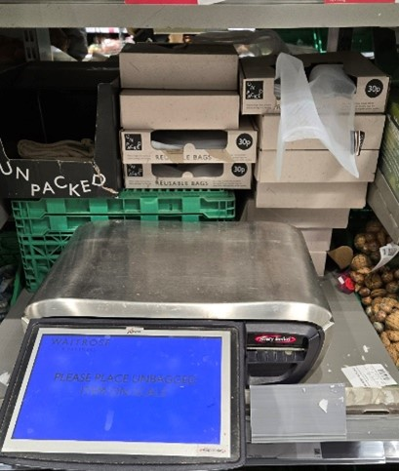
ALDI: reusable produce bag

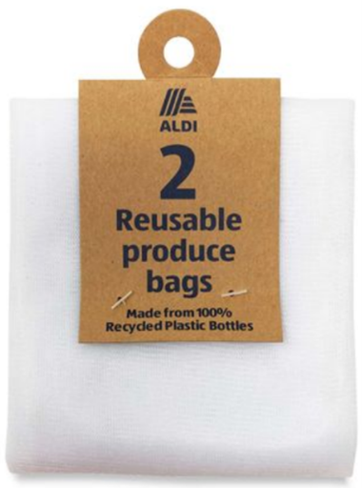
Canadian grocers who are encouraging consumers to transition to reusable produce bags include Sobeys. In the absence of the withdrawal of single-use plastic produce bags, consumers' uptake of this option is slower than has occurred in the UK. A retailer would place themselves at a distinct competitive disadvantage by unilaterally withdrawing single-use plastic produce bags or, due to their cost discrepancy compared to plastic, only offering reusable mesh bags.

Comparative functionality
A number of potentially surprising findings arose from the analysis of respondents' views and experiences surrounding the comparative functionality of paper- or fibre-based alternative packaging, or sale of loose, versus current optimized plastic packaging. The findings are summarized below. A more detailed comparison of specific packaging functional performance for the 6 items studied can be found in Appendix C.
Based on respondents' experiences and knowledge of alternative packaging materials (paper and fibre), the comparative functionality matrices presented in Appendix C confirm the findings from the literature review and retail audits. In general, the less robust and more perishable an item, the greater the gap in functionality between paper and fibre packaging versus plastic. The differences are, however, not seismic.
Differences in the functional performance of alternative packaging versus paper are moderately less noticeable for fruits versus vegetables. For certain functions in relation to specific products — such as onions, lemons and tomatoes — alternative packaging can perform better than plastic. Reasons for this include, for example, the susceptibility of mould to negatively impact onions' quality and shelf life due to their sweating in plastic packaging. As well, differences in the functionality of alternative versus plastic packaging are generally less noticeable at the point of their packing and at the point of their purchase than along the value chain during their distribution. This latter point does not, however, negate the importance that consumers place on inspecting fresh produce prior to its purchase.
A caveat to this categorization of fruits' and vegetables' suitability for transitioning away from plastic is that individual circumstances, including value chains' length and complexity, can influence each produce item's suitability (or not) for alternative packaging or in loose format (see Table 4-3). In each table, items are grouped according to the hardiness levels established during the study completed in 2024.
The viability of a transition to alternative packaging depends in part on whether imported items arrive prepackaged, or are received in bulk and then graded and packaged into retail-sized formats upon receipt in Canada, or are in relatively close proximity to the Canadian market. If products are shipped in bulk prior to their packaging into alternative materials, the costs associated with that packaging (whether cartons or RPCs) will also be factored into the final price paid by consumers.
The categorization of fruits' and vegetables' potential for transitioning to alternative packaging was guided by findings produced by the 2024 functional performance study and insights voiced by respondents. This categorization does not take into account economic factors or consumer acceptance, nor the merchandizing mechanics associated with discount versus conventional retail stores; they solely reflect the potential for transition based on technical feasibility and food safety considerations.
Table 4-3: Viability of increasing the proportion of total sales sold in alternative packaging
Fruits' comparative potential to transition to alternative (paper/fibre) packaging
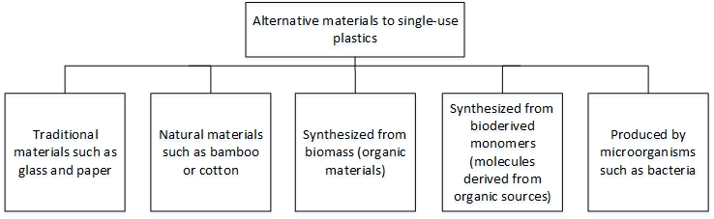
Description of the image above
Vegetables' comparative potential to transition to alternative (paper/fibre) packaging
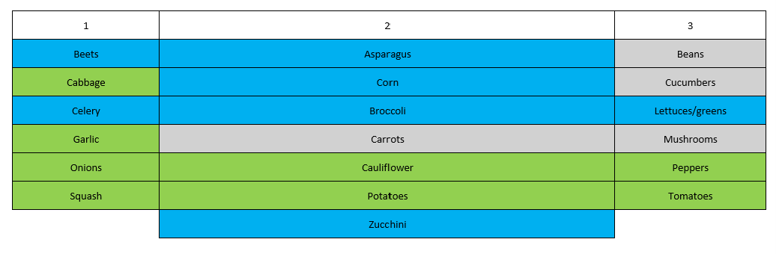
Description of the image above
The above categorization of individual fruits' and vegetables' suitability for transitioning to alternative (namely paper or fibre) packaging materials should be considered directional, not definitive. This is due to the impact of seasonal factors (for example, the importance of plastic packaging to extend the shelf life and availability of imported sweetcorn versus domestic sweetcorn sold loose, due to the degradation that occurs when sweetcorn is exposed to the air for more than a few days).
Nearly all respondents cited that transitioning to alternative packaging will place greater emphasis on proper cool chain management, and in-store display maintenance. This is because alternative packaging is more susceptible to moisture, which can compromise its structural integrity and appearance. Improving the management of in-store displays will require additional labour and, most likely, an increase in staff training and monitoring, all of which carry cost implications.
In addition to its robustness, an item's size (for example, beefsteak versus grape tomatoes) and quality (for example, grade A versus grace C) will affect its potential for transitioning to loose sale (refer to Table 4-4). Certain items (for example, asparagus) will need to be banded, and seasonality and source will also influence an item's suitability for loose sale (for example, as noted above, imported versus locally grown sweetcorn).
Table 4-4: Viability of increasing the proportion of total sales sold loose
Fruits' comparative potential to transition to transition to sale of loose
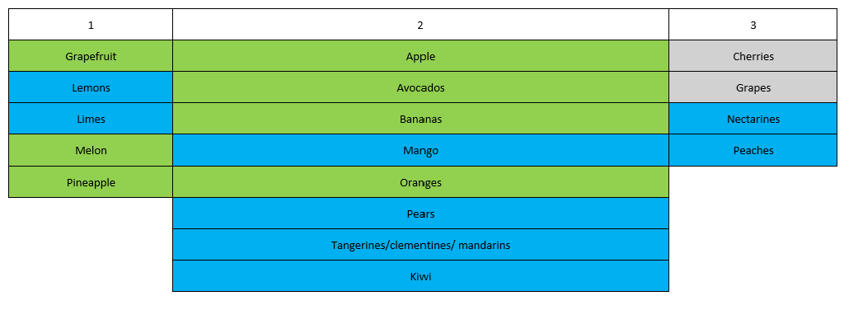
Description of the image above
Vegetables' comparative potential to transition to sale of loose
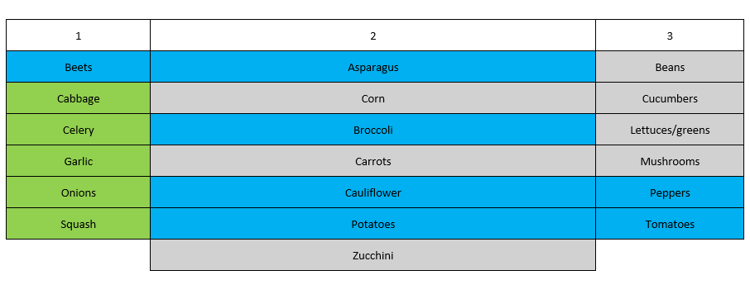
Description of the image above
Interestingly, a number of respondents stated that transporting many of the items studied (including more perishable items such as grapes or cherries) without primary packaging, such as cartons or RPCs, does not automatically lead to increased shrink during transportation. The increased quality issues and higher shrink rates arise from how items react when exposed to ambient conditions, handled by packers or store employees, and later inspected and purchased by consumers — contrasting with the lower shrink typically seen when items are prepackaged at the point of entry into the value chain.
As with alternative packaging, almost all respondents cited that a transition to loose format places increased emphasis on the correct management of the cool chain, and the management of in-store displays. Improving the management of in-store displays will require additional labour and, most likely, an increase in staff training and monitoring. All of this has cost implications.

Cost analysis and implications
The following section summarizes the cost implications of transitioning to alternative packaging or loose formats. It commences with background insights derived from the literature review, informal exploratory discussions with 13 industry experts at the project's outset, and detailed consultations with 29 commercial experts and 5 advocacy group representatives. The section continues by presenting a price increase scenario for particular items that have proven to be suited to sale in alternative packaging or loose format (that is, apples and tomatoes). It outlines findings from the analysis of primary data, which informed the development of the apple scenario presented. The section concludes by presenting findings relating specifically to RPCs, along with a suggested path forward to encourage broader industry acceptance of RPCs where transitioning from single-use packaging, such as cartons to RPCs, is operationally and financially viable.

Background
Since 2020, the average minimum wage has increased by approximately $4.14 per hour across Canada (plus approximately 22% employer EI and CPP contributions). In Ontario and Quebec, the increase in minimum wage has been $2.20 and $3.75 per hour, respectively.^{note 49} During the same period, the cost of all types of packaging materials has risen significantly. Packers are under increasing pressure to reduce input costs as retailers are not prepared to accept price increases. A combination of increasing labour costs and labour shortages has driven many packers' decisions to invest in packaging automation. This investment extends beyond new equipment and offices to include time, research and funding aimed at optimizing primary packaging materials and design, along with determining the correct size and design of master cartons.
While transitioning to loose could reduce suppliers' operation and packaging costs to varying degrees, for reasons cited in the literature review and by respondents, the overall cost implications of the operational inefficiencies associated with loose (particularly those incurred by retailers) will typically translate to an increase in prices paid by consumers. This is because reducing a portion of the 5 to 7% of prices paid by consumers that is associated with current packaging does not outweigh the cost of increased labour, shrink, etc. Hence, as identified by the Canadian store audits, a 39% price differential by weight ($/kg) can exist between apples purchased loose versus packaged. Based on a bag of apples weighing 3 pounds (1.36 kg), the point at which consumers would benefit financially from purchasing loose are those (consumers) wanting to purchase 47% fewer apples (by weight). This comparison ignores quality, size, varietal, source, and packaging material considerations.
Regarding the implications of transitioning to alternative packaging, those involved in the produce value chain with whom we spoke understand the processes and cost of incremental change within their existing business model. They were, however, generally unable to provide more than a rough estimate of the costs associated with a move to alternative packaging, regarding it as hypothetical. This included most enterprises that had partially transitioned to alternative packaging for some of their produce. However, due to cost implications and low market acceptance, none of the businesses we spoke with had fully transitioned to alternative packaging. In the words of an international produce industry representative: "Businesses need long-term assurances before investing in new equipment and processes. The costs and risks associated with transitioning to alternative packaging are presently too high for all but those for whom sustainability is a core tenant of their commercial strategy."
Many respondents indicated that adopting alternative packaging would likely supplement rather than replace existing methods. This is due to low market/customer demand and the infeasibility of transitioning all production to new packaging at once. Additionally, respondents noted increased costs associated with alternative packaging can often only be justified or absorbed in high-value markets.
Consequently, transitioning to alternative packaging would require additional space (facilities) and new equipment. Respondents estimated that consumer prices could increase by 10 to 20% as a result of shifting to alternative paper or fibre packaging. However, respondents also commonly cited that they were uncertain of the full impact on consumer prices that would result from a widespread transition to alternative packaging. At present, many companies are absorbing some or all of the cost implications associated with the transition to alternative packaging, because it represents a small amount of their total business. The lower price increased cited by respondents, compared to the scenarios presented below, reflects the fact that most changes made so far have been relatively straightforward and did not require any capital investment.
With retailers not prepared to increase prices for fear of losing market share, in a number of cases the transition to alternative packaging was only possible because it involved a small proportion of an operation's overall business. In these cases, subsidizing the cost of alternative packaging to retain a customer's overall business was viewed as a necessary expense. In the words of one respondent: "We could not afford to convert our entire program, or a customer's entire program, to alternative packaging." An important factor behind this limitation is the considerably higher equivalent full-time (EFT) labour and measurably slower rate of (per hour) productivity associated with a transition to alternative packaging, due to the lack of automation.
Multiple respondents pointed out that distributors and retailers apply markups based on the initial cost of the product purchased from producers and packers. As a result, any upstream costs increases are compounded through percentage-based markups, potentially leading to significant price increases at checkout. This scenario is outlined below in Table 4-5.
Packaging materials currently in use have been selected based on achieving functionality along the value chain. As outlined in the association matrices developed by VCMI and presented in relation to alternative paper/fibre packaging (Appendix C), the primary functions are containment, convenience, communication, and protection. Depending on the product and point in the value chain, the impact and necessity of specific packaging functions varies.

Price increase scenario — apples and tomatoes
Using apples and tomatoes as examples, we can see the potential impact of increased packaging costs on consumer prices. A review of pricing from 10 Canadian supermarkets for 3- to 4-pound bags of apples and 0.75- to 1-pound plastic clamshells of tomatoes found that apples were selling for an average of $2.11 per pound and tomatoes were selling for an average of $6.39 per pound.
Based on the information gathered during the expert consultations, if alternative packaging costs the equivalent of $0.70 per pound for apples compared to about $0.11 per pound of apples in plastic packaging, the resulting retail price would increase by 42%, bringing the price to approximately $3.00 per pound. For tomatoes packaged in clamshells, alternative packaging of a paper or fibre base with plastic top seal would cost $0.70 per pound, compared to $0.25 per pound for a plastic clamshell. The resulting retail price would increase by 11% to $7.07 per pound (see Table 4-5).
This calculation assumes that 100% of the increased costs are passed along to the consumer. It also assumes that the product is being purchased by the retailer directly from the producer or packer without incurring distributor markups. If the product were to pass through an independent distributor, additional price markups would apply, further increasing the retail cost.
The price of a produce item will increase by the difference (delta) between the cost of the alternative packaging material and the produce item's current packaging, plus a minimum 50% markup. This markup is based on insights from produce retail experts and provides the expected 33% gross profit margin at checkout. Some markup estimates were considerably higher; therefore, this should be viewed as a conservative estimate, and actual price increases may be higher. This is particularly the case when changes in product format (for example, carton versus a bag) result in incremental changes to associated costs, such as the packing process, storage, delivery, shrink, or in-store operations. See Section 4.4.4.
Table 4-5: Simple scenario-impact of higher material cost on consumer price
 | Original price ($/lbs) in plastic | New price ($/lbs) in alternative material | % change in price
Apples in bag | 2.11 | 3.00 | 42
Tomatoes in clamshell | 6.39 | 7.07 | 11
The results show that price differentials are significantly more noticeable when the product and the packaging in particular have low financial value. Plastic bags in which apples are currently packed are much cheaper than paper and fibre alternatives, which in this case, is a cardboard box. If the same packaging cost increase was applied to a higher value item, whose packaging was already more expensive than plastic bags (for example, tomatoes in clamshells), then the cost differential is much less noticeable (11% versus 42%).
Both scenarios would result in price increases above the threshold at which retail respondents stated they typically begin to see a reduction in purchase volumes — approximately 6%, as previously mentioned.
This simple example illustrates why most of the transition in packaging materials that has occurred to date is in higher value premium items.

Current packaging material costs
The research found that packaging materials typically account for 5 to 7% of the retail price of fresh produce (see Table 4-6). Based on the average price of the 6 products under review, the maximum price for packaging for higher value premium^{note 50} items (as a proportion of prices paid by consumers) would therefore be approximately $0.45 per pound. If the cost of alternative packaging does not fit within the current cost parameters, it will likely result in higher consumer prices, as the thin margins that characterize the fruit and vegetable sector cannot absorb additional costs.
Table 4-6: Estimated current packaging cost as a proportion of retail price
Produce item | Retail $/lb^{note 51} | Current packaging material cost ($) (per/lb as % of retail price) |  | Current plastic packaging in which typically packed
Produce item | Retail $/lb^{note 51} | 5% | 7% | Current plastic packaging in which typically packed
Carrots | 1.32 | 0.07 | 0.09 | Bag
Onions | 1.38 | 0.07 | 0.10 | Bag
Apples | 2.11 | 0.11 | 0.15 | Bag
Grapes | 4.14 | 0.21 | 0.29 | Pouch
Lemons | 5.33 | 0.27 | 0.37 | Net
Tomatoes | 6.39 | 0.32 | 0.45 | Clamshell
The packaging costs as a proportion of retail price per pound shown above is directional only. They are based on the median cost established from analyzing respondents' data. The actual cost of packaging as a proportion of the retail price is dependent on multiple factors, including quality, tensile strength and format. For example, the above cost for tomatoes is based on a plastic clamshell. For tomatoes packaged in a bag, the cost differential would be closer to that shown for carrots, onions or apples. Hence, differences in the comparative cost implications on end price of packaging premium versus commodity items in alternative packaging vary considerably.

Cost implications beyond material
Changing packaging materials is only one aspect of the cost implications associated with a transition to alternative packaging. The impacts of packaging changes extend throughout the entire value chain. Therefore, respondents were asked to comment on the cost implications across the whole chain.
Separated into recurring (variable) costs and non-recurring (fixed) costs, a summary of the chain-length cost implications of transitioning to alternative packaging, and the packaging of loose items into RPCs is presented below.

Recurring costs (variable costs)
Table 4-7 summarizes the expected impact on costs (percentage increase or decrease) in relation to operations performed along the value chain for each of the 6 items that formed the primary focus of the study.^{note 52} Due to the confidential nature of the data provided by respondents and the variation in costs associated with different products, grades and packaging materials and formats, along with seasonal related supply and demand factors, the data for all 6 items has been combined to provide a defendable estimate of the potential impact of 2 scenarios. These scenarios assess recuring variable costs at different points along the value chain and the findings should be viewed as directional, not definitive.
The scenarios are titled "Alternative Packaging" and "Loose in RPCs." The first scenario is the estimated impact on variable costs associated with replacing primary packaging manufactured from plastic with primary packaging manufactured from paper or fibre. The second is the estimated variable cost implications associated with transitioning away from any primary packaging, instead of packaging loose, along with having transitioned from cardboard cartons to RPCs.
As most respondents spoke in somewhat hypothetical terms, because for the most part they did not possess firm performance measures or cost estimates, there was variation in the data provided. For example, in one case, the total cost of transitioning to labour-intensive packaging with alternative materials (such as cardboard boxes) for a small seasonal program was estimated to be 24 times higher than the cost of packaging the same weight of this particular fresh produce in plastic bags using automated equipment.
To ensure that results presented in Table 4-6 are conservative and defensible, and therefore inferable across the wider industry in comparison to current performance and costs, outlier data (such as the example described above) was excluded from the analysis.
It is worth noting that respondents highlighted the lower Extended Producer Responsibility (EPR) fees typically associated with paper and cardboard, compared to plastic packaging, as well as the potential revenue stream from recycled paper/cardboard. These factors can offset some of the increased costs associated with transitioning to alternative packaging materials. However, these considerations are not accounted for in the scenarios presented. This exclusion is due to the fact that both EPR fees and recycled material revenue vary by material type and region, and that they are not significant from a per unit perspective.
Table 4-7: Cost implications from a value chain perspective (%)
Operational aspect | Alternative packaging | Loose in RPCs
Packaging material cost | 300 | -20
Packing run rate | -20 | 0
Labour-FTE (Packer) | +20 | -5
Labour-FTE (Distribution) | 0 | -20
Labour-FTE (Retail) | 0 | -40
Shrink | +5 | -5
Transport | 0 | +3
The results show that, typically, paper or fibre packaging materials cost 4 times as much (300%) increase over current plastic packaging. On average, transitioning to paper or fibre packaging results in a approximately 20% reduction in operational performance (run rate) compared to existing systems, while requiring 20% more labour (EFT) to pack the same volume of produce. It is worth noting that similar price and efficiency differentials were commonly noted in relation to transitioning from plastic to certified compostable plastic bags and packaging materials.
The smallest impact on packing line run rates occurred when the design and handling characteristics of the alternative packaging materials were almost identical to the plastic they replaced. Examples of such include a mechanically filled paper or fibre bases with top seals replacing mechanically filled plastic bases with top seals; or a hand-packed paper pouch grape bag replacing a hand-packed plastic pouch bag. In such cases, plastic and alternative packaging could be interchanged with negligible downtime and only minor changes in run rate.
Packing loose in RPCs was estimated to represent a 20% reduction in packaging material costs. As mentioned, the key challenge with transitioning to loose produce is the lack of consumer demand compared to prepackaged produce and the merchandizing, transaction, and shrink costs associated with loose format. Differences in the run rate of packaging into RPCs versus cartons was typically negligible. Other than a moderate decrease in transport capacity, the adoption of RPCs offered the opportunity to capture noticeable improvements in downstream efficiencies — particularly from the point at which shipments reach a retailers' (or third parties') distribution centre.
As noted previously, the research found that any savings from packaging transitions are likely to be absorbed as profit and not passed along to the consumer. Cost increases are more likely to affect consumer prices than cost decreases. Thus, any cost increases that occur along the value chain due to machine and labour inefficiency, transportation and shrink will result in price increases that are considerably greater than those only associated with the cost of alternative materials.
Interviewees also emphasized that differences in shrink, sales velocity, and in-store merchandising tactics contribute to the cost differentials observed between loose and prepackaged produce. For example, shrink will increase when lesser-quality or inconsistently sized produce is sold loose, while prepackaged formats benefit from faster inventory turnover and lower transaction costs. The need to actively manage the dynamic interplay that exists between these product quality and uniformity related factors can influence retail pricing strategies more than differences in packaging costs.

Non-recurring costs (fixed costs)
The packers to whom we spoke have extensively invested time and resources into investigating alternative packaging materials, including paper and fibre-based options. Like other packers, they have also made significant investments in automated machinery acquired over the years. We were told that capital investments of this type are typically amortized over a 10+ year timescale, hence the decision to purchase automated packaging equipment is not taken lightly or without packers being assured of the long-term feasibility of their investment. Investments in current equipment has enabled them to become highly efficient at packing produce into plastic bags and punnets. In an industry typified by thin margins, all respondents stated that few packers will voluntarily invest in the equipment required to pack fresh produce in alternative materials at an equivalent level of efficiency, and adopt what they called a "wait and see what happens" approach. This is particularly the case for small- to medium-sized packers, who together form the majority of the produce industry worldwide by volume.
Respondents stated that the capital expenditure required to efficiently pack using alternative materials will differ significantly, depending on whether existing equipment can be converted or if it must be completely replaced. The cost of replacing each dedicated automated bag machinery, such as those used to fill 3-pound bags of apples from roll-stock plastic, could cost $500,000 or more. It is likely that substantial investments would be needed in pack line and ancillary equipment. Remaining competitive in an international market, especially if they export any of their production, would likely require a company to both retain current equipment and purchase new. The capital cost of doing so would increase exponentially, given the need to invest in additional real estate, facilities and infrastructure etc.
According to respondents, companies that pack fruits or vegetables for export to Canada are even less likely to invest in the capital required to efficiently pack produce in alternative materials. They questioned why they would risk reducing competitiveness and financial stability to continue serving a market that, for many businesses, only represents a small percentage of their total production.
For businesses currently packing fresh produce into clamshells (such as peaches, grapes or tomatoes), respondents stated that they typically possess some capacity to convert existing equipment to pack with alternative material. This allows for conversion without incurring the same level of capital expenditure required for other types of packaging transitions. A number of respondents anticipated that, even after converting equipment, they would still incur a measurable reduction in production capacity and performance. In the scenario above, a 20% reduction in run rate was used to reflect this. Factors contributing to the slowdown include the longer time required to apply a top seal to paper and fibre compared to plastic.
For these reasons, a number of respondents (including retailers) said that the widespread change required to cause packers and others to invest in the equipment and capabilities required to automate the packing of alternative materials will likely require a carefully crafted combination of regulations and government financial support.
For businesses that currently pack produce into single-use cardboard cases, converting to RPCs would typically have less impact on operational performance and require lower capital investment. There is an expectation, however, that RPCs require more storage space and will lead to changes in transactional procedures to maintain the tracking and reuse of RPCs. Both factors have cost implications.
Figure 4-2, uses $ symbols to illustrate the scale of cost implications associated with converting to alternative packaging materials. The figure highlights areas where this conversion is expected to require capital investment and impact supply/value chain performance, including additional labour requirements.
Figure 4-2: Cost implications associated with the transition to alternative packaging
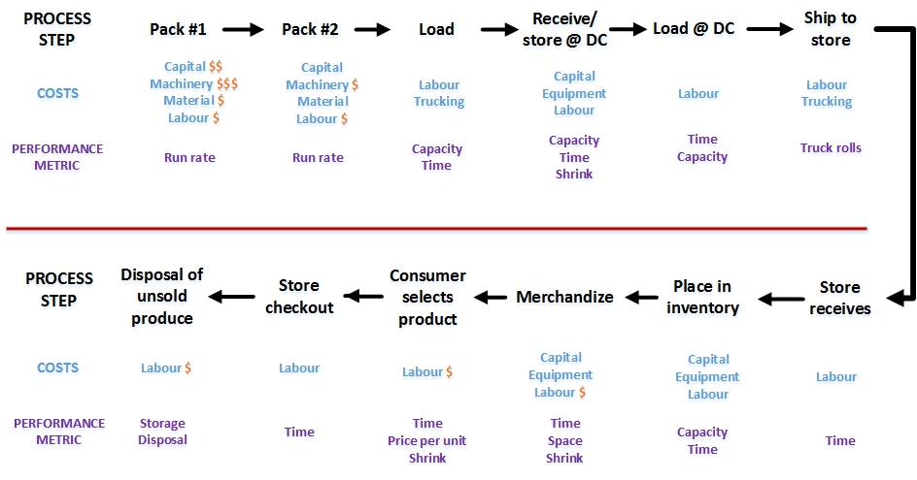
Description of the image above
Data provided by both respondents and the literature review showed that benefits can be derived from transitioning to RPCs for the transport and distribution of produce packed in alternative materials and loose (see Figures 4-3 and 4-4). In these figures, dollar "$" symbols are used to represent the scale of cost implications. This is where the utilization of RPCs could require capital investment and impact value chain performance, including changes in labour requirements. Brackets ($) are used to indicate where a reduction in operating, transaction and labour costs have been attained due to increased efficiencies through the use of RPCs.
Figure 4-3: Cost implications associated with transitioning to RPCs for alternative packaging
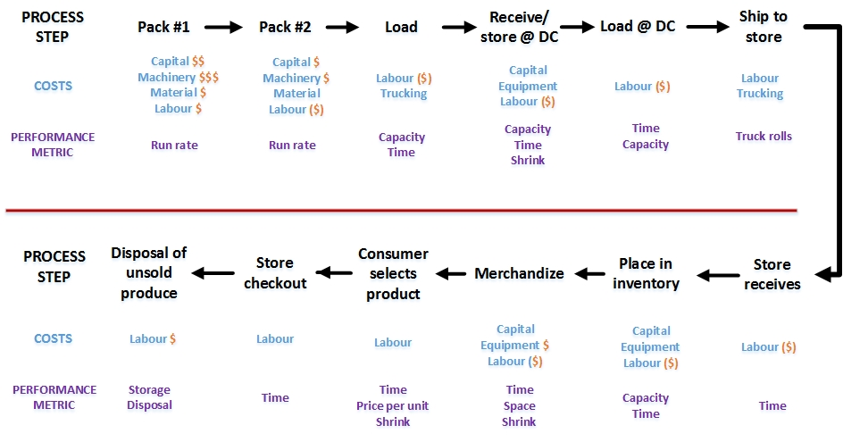
Description of the image above
As evidenced in the UK and Europe, where a wide range of packaged and loose products (not only produce) are transported and distributed in RPCs, transitioning to RPCs could help offset issues related to the lower tensile strength and store labour concerns associated with some alternative packaging materials. The increased ventilation offered by RPCs compared to traditional cardboard cartons could also improve the cool chain's effectiveness, which a number of respondents said will be key to successfully transitioning to alternative packaging due to its susceptibility to moisture buildup.
The potential for greater efficiencies downstream, particularly in DCs and retail stores, along with reduced shrink from the RPCs robustness and stability on the skid, could offset a proportion of the increased costs associated with the transition to alternative packaging. The actual amount to which this would equate in relation to prices paid by the consumer would differ by item and value chain. Whether the use of RPCs could encourage Canadian consumers to view alternative packaging in a more favourable light is unknown.
Figure 4-4: Cost implications associated with transitioning to RPCs for loose produce
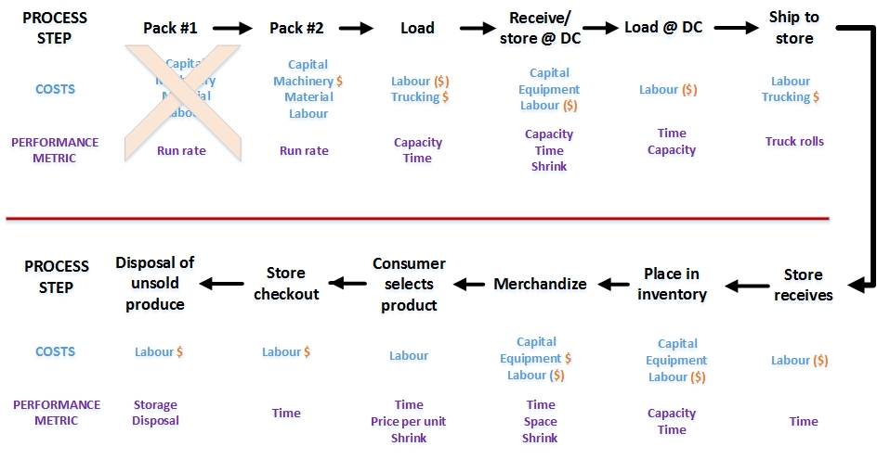
Description of the image above
As can be seen in the above, when packing loose produce into cartons or RPCs, there are no primary packaging costs associated with the product. This, along with the increased downstream efficiencies and reduced shrink due to less damage and handling during distribution and merchandizing, could result in loose produce being sold at prices that are equivalent to or slightly lower than produce prepackaged in plastic. Since the net cost savings of transitioning from single-use packaging to bulk are minimal, given that total packaging costs typically equate to approximately 5 to 7% of the price paid by consumers, and only a proportion of those costs are saved when switching from packaged to loose, the impact of RPCs on driving operational efficiencies is where the main potential cost/price benefits lie. The potential impact of increased operational efficiencies on prices paid by consumers may therefore be greater than potential benefits associated with a reduction in single-use packaging.
The exact difference in costs and prices would therefore differ by item and value chain. Whether these potential lower costs and subsequent reductions in the price of produce compared to those currently paid by consumers, through the use of RPCs, is sufficient to encourage a higher proportion of Canadian consumers to purchase loose versus prepackaged is unknown. As evidenced by insights that emerged during the literature review and by industry respondents, consumer purchasing decisions are influenced by factors beyond price.

Recommendations and future research

Reusable plastic crates
The research findings suggest that the best immediate opportunity to achieve a measurable reduction in overall packaging, not just plastic packaging, is by encouraging the industry to switch to RPCs. For reasons described, this transition could assist in a subsequent or simultaneous transition to alternative packaging. In the words of a respondent in Australia, where RPCs for both loose and packaged fresh produce have been more widely adopted than has occurred to date in Canada and more recently than occurred the UK: "The industry came together on RPCs because it was a practical way to demonstrate their seriousness to reduce single-use packaging and increase supply chain efficiencies. Not being ideologically driven meant that there was less to dispute."
Several reasons were identified, and individuals' opinions vary greatly, as to why a transition to RPCs may or may not offer similar opportunities for the Canadian fresh produce (and potentially the wider food) industry as they have for the UK and Europe. Table 5-1 outlines the perceived barriers and potential opportunities throughout the value chain regarding the adoption of RPCs. Each of these factors must be thoroughly explored before the wider industry will adopt RPCs.
Table 5-1: Perceived barriers and potential opportunities of RPC adoption
Chain element | Perceived barriers | Potential opportunities
Grower/grower packer | - Not legislated, so will not invest time or resources exploring the suitability of RPCs for my operation  - No guarantee of success  - Lose current investment  - It will not work | - Conduct a funded no-risk pilot  - Not impacted by $ increases to existing material  - Likely cheaper than current case price  - Pooled resource = no shortages  - No (at least lower) EPR fees  - No (or fewer) plastic registry accountabilities
Truck line | - It is different  - What happens if a load is rejected at retail | - Standardized packaging and skids  - Improved temperature control  - Loads less susceptible to moisture buildup  - It works elsewhere
Distributor | - Another thing to contend with  - What do we do with the empty RPCs?  - What happens if a load is rejected? | - Ease of receiving, put away  - Ease of pick pack and ship  - Improved inventory accuracy  - No (at least lower) EPR fees  - No (or fewer) plastic registry accountabilities
Retailer | - It is different/it will not work  - Will not fit in current display cases or cold shelves  - Too much to deal with returning RPCs to dunnage centre  - Customers will buy less produce  - Will not look attractive to consumer | - Ease of receiving and put away  - Ease of merchandizing/re-stock  - Less packaging to break down and dispose of  - Replace a cost (providing flimsy plastic bags) with a revenue source: the sale of washable net bags  - One company removes  - Make displays attractive to consumer  - No (at least lower) EPR fees  - No (or fewer) plastic registry accountabilities
Consumer | - It is different  - What do I put loose items in?  - Is this item safe, who else has touched this item?  - More difficult to pack, unpack and put away | - Smaller displays mean produce has been touched by fewer people and less time out of cold chain  - Continue with flimsy plastic bags and/or sell washable bags in the produce area  - Less single use plastic (SUP) packaging to be disposed  - Do not have to buy a package when I only need 1 or 2 items
For RPC implementation to succeed, it must be driven by retailers rather than pushed by growers and packers. The implementation of RPCs can reduce the need for primary and secondary single-use packaging, while also decreasing the associated tasks of purchasing, stocking and disposing of existing packaging material.

Further research
To progress beyond opinions and qualitative assessments, some applied action research^{note 53} in the form of a funded pilot would provide implementation data and a cost-benefit analysis to support and guide RPC adoption.
This could be achieved through a structured and collaborative approach as follows:
- Conduct a fact-finding visit to the UK or EU with a group of interested stakeholders, including key retailers to determine how RPCs would be implemented in Canada.
- Establish a coalition of willing stakeholders representing the entire value chain, with an independent oversight group to thoroughly evaluate the opportunities and challenges associated with a transition to RPCs across a variety of circumstances. These circumstances should encompass domestic and international trade, diverse value chain structures and various types of fresh produce.
- Secure government funding for 18 to 24 months to cover a portion of the implementation costs (excluding capital investments) of transitioning to RPCs. Any additional equipment would be leased for the stakeholder by the project funding.
- Establish a project plan with agreed-to roles and responsibilities, major milestones and clear performance measures.
- Establish a whole-of-chain RPC process with a Failure Mode Effects Analysis (FMEA) to identify and monitor potential risks throughout the project.
- Execute the established project plan as outlined in (4).
- Have the oversight group conduct monthly reviews to track progress, address issues and ensure alignment with project goals.
- Each stakeholder provides an end-of pilot report out to the oversight group.
- Have the oversight group prepare the final report to the project funders.
- Based on the final report, the next steps/path forward plans would be established for broader RPC adoption and scalability.

Alternative packaging
In the words of a respondent who has worked with numerous fresh produce vendors and customers to successfully introduce fresh produce in paper and fibre packaging to the market: "Too many packaging material suppliers expect industry to modify their produce packaging systems to suit their materials. This drives up costs and makes the adoption of alternative packaging financially unfeasible. You need to look at the whole system, not just one element of the system in isolation." Another respondent, a highly experienced director of packaging procurement and evaluation, stated how the above factors — along with alternative packaging materials not currently being available in the volumes required to mount a mainstream retail program — made an estimation of the impact on cost at a per unit level "incalculable."
Close to 80% of industry respondents stated that insufficient information exists for them to make informed packaging, capital, process, and market positioning decisions when considering alternative materials. Much of the information that exists, they said, has been produced by someone with a biased agenda and cannot be acted upon in good faith. Produce industry veterans who want to do what they described as the 'virtuous' thing and reduce plastic packaging in the fresh produce industry, and who possess decades of experience, were among those that voiced the view that insufficient actionable information is currently available to industry. In the words of a producer representative: "Both the cost and risk of transition are presently too high. It's not that growers are resistant to change, it is that things cannot be viewed in isolation. Taking an objective holistic systems approach is imperative." Similar sentiments were voiced by retail respondents, including those who are working with vendors to pilot alternative packaging materials.
The comparative cost of alternative packaging versus plastic is indeed a challenge. The greatest challenge, however, is differences in value chain efficiencies associated with alternative versus plastic packaging and the investments required to close that gap. For the reasons described above and in previous sections, neither packaging equipment manufacturers nor the produce industry are investing in physical capacity required to enable and drive widespread change. As well, consumers' negative reaction to non-transparent packaging materials is a huge challenge, which must be overcome for alternative packaging to become mainstream. Consumers' displeasure with non-transparent materials, regardless of any price implications, was evidenced by the research findings. It is not solely about changes in costs and prices.
The present situation relating to the expanded use of alternative packaging is much different to that which relates to RPCs, which is a proven technology; and Canada can learn from systems and processes that have been successfully established domestically and in other jurisdictions. The process to engage industry (and consumers) in the development and adoption of alternative packaging, which is a new technology, needs to follow a systemic design/test/commercialize process that encompasses parties from along the value chain.
Table 5-2 outlines the perceived challenges and risks that must be considered and addressed through a reiterative action research process that encompasses the entire value chain. Each of these factors must be thoroughly explored before the wider industry will adopt alternative packaging on a broad scale.
Table 5-2: Alternative packaging design, test, commercialize process
Chain element | Challenges | Risks
Designer | - Ensure food integrity and safety  - Cost to design, test, commercialize  - Must be recyclable | - May not work, so do a trial run  - May cost more than existing packaging  - Recyclable but not recycled
Package manufacturer | - Breaking new ground; new material and process to handle  - Likely have a minimum run quantity (high $$)  - Existing packaging production capacity becomes redundant | - What if it doesn't work? Who bears the cost: designer or manufacturer?
Grower/packer | - Won't invest $$ in alternative development costs  - Need assurance they are not penalized or handicapped by possibility of having to revert to plastic | - What if alternative fails along the value chain, who is liable?  - Have to pack at a lower run rate  - Redundant SUP pack line = increased overhead costs
Truck line | - Ability to ship at same rate and maintain cool chain integrity  - May need alternate material handling equipment | - Increased liability if loads packed in alternate packaging are ineffective at maintaining products' quality or/are rejected on receipt by customer
Distributor | - Ability to receive, pick, pack and ship at same rate  - Shrink greater than existing SUP  - Another new thing to deal with | - Shrink increases  - Per hour/person/facility productivity rate slows  - Costs increase
Retailer | - Another new thing to deal with  - Consumer resistance acceptance | - Costs increase  - Consumers choose store whose remained with SUP  - Weakness in alternate packaging materials' performance will be most demonstrated here = increased shrink
Consumer | Resistance  - Looks different  - Can't see contents  - Won't last as long | - Try it once, don't like it — vote with their feet, shopping at different store or purchasing an alternative product  - Increased shrink
In summation, the key risks that must be explored and addressed during the process outlined above are:
- May work on short domestic chain, not on longer complex domestic and international chains
- Packers supplying different markets may need an additional packing line, leading to higher costs due to need for increased
  - Space/plant
  - Line equipment
  - Tooling
  - Training and supervision of personnel
- Decrease in sales revenue and/or margin
- Shrink increases along the chain, driving up total GHG emissions and incurring additional costs
- The overall solution leads to involved businesses paying higher EPR fees
The process outlined above would also assist in the design and introduction of the carefully designed and executed policies, legislation, and regulations, which numerous respondents stated as being important for creating an enabling environment suited to causing businesses to view alternative packaging from a longer-term perspective. Most respondents stated the need for policies, legislation and regulation that support the establishment of circular economies for all types of packaging.
The existence of such an enabling environment is key to providing businesses with the confidence to invest capital and operating expenditures into establishing alternative packaging systems whose efficiencies closely match those associated with plastic packaging. The importance of carefully planned policies, legislation and regulation is underlined by their potential to measurably drive up food prices and interfere with the availability of imported fresh produce.
Interviewees' comments about the role of regulation supporting packaging transitions generally fell into 2 categories. First, regulations that require all suppliers to transition to alternative packaging or sell produce loose, provided that such a transition is economically viable for industry and consumers. Second, regulations designed to motivate and enable the creation of sustainable circular packaging economies.

Conclusions
The purpose of this research was to provide a better understanding of the cost implications (net positive and/or negative) and potential benefits associated with a reduction in the primary plastic packaging of fresh produce sold in Canada. Potential benefits and challenges associated with a transition to RPCs, for fresh produce sold loose or preplaced, was also explored. These objectives were achieved by researching the feasibility and net cost/benefit implications of reducing non-essential plastic packaging for 6 selected fruits and vegetables: one respectively from each of first 3 categories of fresh fruits and vegetables established during the prior study, and infer research findings across the wider industry. In so doing, the study examined the cost implications (net increase or net savings, accounting for avoided costs where applicable/feasible) of solutions that industry could undertake to reduce the use of plastic packaging for produce.
The research findings show that opportunities exist to reduce the proportion of fresh fruits and vegetables sold prepackaged in plastic. Many of the responding growers and packers/distributors have transitioned a small proportion of their production to alternative packaging. The respondents who had established dedicated lines packaging produce in cardboard or fibre, typically with a plastic top seal lid, did so to supply a distinct sustainability-conscious segment of the market; and their transition reflected a long-term perspective without having to absorb high capital investment costs.
The literature review and the analysis of research respondent data found that the primary challenges associated with a transition to alternative materials in the fresh produce items studied relate to economics more than function. Hence, the majority of the Canadian fresh produce industry has not transitioned to alternative packaging, and lacks the commercial motivation and capabilities to do so on a widespread basis. Therefore, while almost all industry respondents consulted during the study support such a transition in principle, its implementation is occurring slowly across the broader industry.
The most notable challenges associated with a transition away from primary plastic packaging, whether by increasing the proportion of items sold loose or packed in alternative materials, is gaining consumer acceptance. As noted by a number of respondents during this and the prior study completed in April 2024, and in the literature review, consumers are adamant about seeing the produce before deciding to make a purchase. For reasons pertaining to value, convenience and health, even those consumers who voice an interest in purchasing loose often tend to purchase prepackaged. These consumers account for the majority of fresh fruits and vegetables purchased in Canada. The importance consumers place on inspecting produce prior to purchase was evidenced by respondents' first-hand experience of significant sales declines after switching to alternative (non-transparent) packaging materials. Sales returned to previous levels when the vendor returned to packing in SUP. This occurred regardless of whether the change in packaging materials was accompanied by an increase in price.
Three key factors were commonly observed in cases where a transition to alternative packaging materials led to a measurable increase in sales: 1) the general appearance of the packaging remained similar to the previous version, 2) the packaging enhanced the product's overall value proposition, and 3) consumers could inspect a good representative sample of the produce prior to purchase.
The research also identified that, while solutions exist to address consumer reluctance to purchase fresh produce in non-transparent materials, overcoming this takes time and requires investments in marketing and product positioning. This is particularly challenging for low value commodities compared to higher value premium products. Identifying means to encourage consumers to become more accepting of alternative packaging materials, regardless of any associated price implications, is clearly required. As suggested in Section 5.2, this process could be most effectively undertaken by encompassing the entire value chain in the design, development and commercialization of cardboard and fibre packaging.
The scenario analysis identified that the cost implications of transitioning to selling produce loose or packaged in alternative packaging could range from approximately 11 to 42% of retail prices paid by consumers. It also identified that the cost implications of transitioning to alternative packaging materials extend beyond the cost differences between the packaging materials. The lowest cost implications occur when the transition to alternative packaging does not require reengineering the packing line and the new packaging is of similar size and shape to the existing packaging. An example is packing tomatoes in a paper or fibre base with top seal, versus the current plastic base with a top seal. A grower/packer supplying a distinct segment of the consumer market had implemented this approach for a different item (not tomatoes), dedicating a production line to packing in a fibre base with plastic top seal lid.
The greatest cost implications of transitioning to alternative packaging are in commodities that are of comparatively lower value by weight (for example, apples), and require the adoption of much different packaging from what is currently used. This transition would require considerable investments in equipment and facilities. Without investments in capital, equipment and processing capacity, high velocity automated packing is impossible.
Selling produce loose would reduce packaging costs and the overall volume of plastic packaging. Respondents, however, believe that this option has limited opportunities due to low consumer demand for loose versus prepackaged produce, and the economic feasibility of loose resting on products' robustness and quality. The adoption of RPCs in place of single-use packaging could increase supply chain efficiencies and allow a moderately larger proportion of the total crop to be merchandized loose, where circumstances allow.
Given that plastic packaging typically equates to 5 to 7% of an item's retail price, transitioning to loose would not necessarily result into reduced prices. Using apples as a notional example, the research identified that primary financial benefit of having the option of purchasing loose would be captured by those consumers who wish to buy 47% fewer apples (by weight) than if purchasing a pack of items. This finding is based on weight only. It ignores size, quality, source and packaging material considerations. Quantifying the effect of individual retailers' cost structures and marketing strategies on differences in the prices paid by consumers for loose versus packaged produce was beyond the scope of this study. Additional granular research is required to determine the full impact of these enterprise-level effects.
Examples mentioned by a number of respondents and identified during the store audits regarding how UK retailers have further reduced the volume of plastic packaging associated with fresh produce is by having withdrawn the single-use plastic produce bags that are typically found in most Canadian retail stores' produce departments. In the absence of such bags, a large proportion of UK consumers use reusable mesh bags. Canadian retailers are offering this option of reusable mesh bags to consumers, though to date it has experienced limited uptake. A Canadian retailer would place themselves at a competitive disadvantage by unilaterally withdrawing single-use plastic produce bags. Hence, as occurred in the UK, this transition would be best achieved pre-competitively, with the majority of (or all) retailers simultaneously transitioning over a period.

Appendix A: Reusable plastic crates
Germany set the bar for recycling packaging in 1991, when the country created an ordinance requiring businesses to separate and recycle 80 to 90% of traditional packaging materials to keep them out of landfills. This, in turn, created significant demand for reusable plastic crates (RPCs). Other European nations soon set similar standards. Now more than a billion European RPC shipments move from producers to grocery retailers annually, far outpacing the U.S.^{note 54}
In a 2001 interview, Bruce Peterson, then a Walmart vice president, pointed to efficiencies achieved after the retail giant converted 70% of its transport containers to standard-sized RPCs. He referenced advantages including ergonomic handles, interlocking anti-slide mechanisms, stack-ability, collapsibility, and resulting ease of storage. He was also impressed by how RPCs negated the need for store personnel to sort and compact corrugated boxes.
"(They) were very desirable from the grower and shipper end," Peterson added. "Not only were these RPCs standardized, they were display-ready. And because of the airflow accessibility and the way the box is designed, we found that any kind of a pre-cooling operation where you took things out of a warm field and could bring temperatures down was very efficient."
Kroger's website reports that it shipped 106 million RPCs of fresh produce to its stores in 2015 alone, eliminating the use of more than 73,500 tons of waxed and corrugated boxes.
According to Tosca Ltd, a producer of RPCs, RPCs have the following benefits over corrugated cardboard packaging:
- Overall efficiencies: RPCs enable the elimination of value chain wastes including packaging, product shrink, labour, and transportation.
- Better hygiene: Unlike corrugated cardboard, RPCs do not break down into dust that can contaminate products or generate messes in facilities. They are also impermeable, preventing leaks that can contaminate other boxes of otherwise sellable products.
- Better cube utilization: RPCs feature a base that nests into the top of other crates to prevent containers from slipping off stacks. The crates are significantly stronger than corrugated carboard, capable of bearing much more weight. RPCs also stack higher, allowing trucks and small warehouse spaces to be utilized more efficiently by maximizing storage capacity. RPCs provide more efficient transportation in the value chain.
- More protective of contents: The strong walls of RPCs do more than support strong stacks, as they also ensure that the products inside are protected from any crushing that can occur from the weight of the stacks above, or knocks and mishaps during transit from source to store floor. RPCs can reduce shrink by 50% by preserving product quality.
- More sustainable: Only 68% of cardboard and paper that is sent to be recycled in the US makes it through the recycling process, so the remaining 32% ends up in landfills after only one use. With reusable plastic crates, reuse is guaranteed. In fact, most RPCs carry products through the value chain hundreds of times in their lifetime, with each use eliminating the need for an unnecessary single-use box.
- Better transition from transport to display: Many types of RPCs are also excellent display containers. When used for both purposes, RPCs save the store workers the time of unpacking, while also preventing the inevitable product damage caused by more handling. For example, using case ready-meat RPCs can result in a 25% reduction in labour costs.
RPCs also enable the efficient utilization of packaging systems, such as pooling or renting. Pooled reusable products support a strong circular economy, by reducing the environmental and financial impact of return journeys and eliminating the upfront costs for users owning the reusable assets.
There is ongoing debate about the overall environmental sustainability of RPCs. For example, one packaging company, based on a life-cycle analysis, claims that recyclable corrugated packaging consistently outperforms plastic reusable packaging.^{note 55} Further considered assessments^{note 56} indicate that the recyclable corrugated cardboard box (CCB) system is a more environmentally friendly option compared to the reusable high-density polyethylene (HDPE) plastic crate system. This is primarily due to an increase in GHG emissions associated with transporting the heavier HDPE crates. Therefore, changes, for example, in the weight of products and their secondary packaging, transport capacity, or distances travelled, can measurably affect the comparative environmental sustainability of RPCs versus CCBs.
Other evidence^{note 57} shows that one RPC with a 100-use lifespan prevents 100-150 pounds of single-use material from entering the value chain. End-of-life RPCs are recoverable, and 100% of the plastic can be used to make new RPCs. In addition, RPCs require 80% less water and 64% less energy compared to single-use alternatives, as demonstrated in comparative life-cycle analysis.

Appendix B: Discussion guide

Estimating the cost implications of reducing plastic packaging for fresh produce
The 2024 VCMI study, Quantifying the Functionality Importance of Plastic Packaging in Fresh Produce from a Needs/Benefits Perspective, published in collaboration with Environment and Climate Change Canada (ECCC) and Agriculture and Agri-Food Canada (AAFC), identified opportunities to reduce plastic packaging for fresh fruits and vegetables, without risking unintended consequences, including shelf life, food safety and impacting year-round availability.
The purpose of this study is to examine the feasibility and cost implications (net increase or net savings) of eliminating or reducing plastic food packaging for 6 types of fresh fruits and vegetables, by selling loose or transitioning to alternative packaging materials. To capture insights into a range of products and potential packaging/merchandizing formats, the fresh produce items on which the study focuses are lemons, apples, grapes, onions, carrots, and tomatoes.
The alternative packaging that falls within the scope of this project is non-plastic packaging, such as cardboard or fibre (excluding those that are coated with non-natural waxes). The implications of using mixed material packaging are also being evaluated; for example, using a cardboard base and lid that contains a transparent viewing window.
As a respected produce industry expert, we would greatly appreciate your perspectives. Your participation in this study will help ensure that conclusions reached through the analysis of research data is viewed in the context of the Canadian fruit and vegetable industry.
All of the information that you provide will be treated with the strictest confidentiality. We are not seeking the names of people, businesses or organizations. Only the VCMI team will see individual responses and granular research data, both of which will be destroyed at the project's conclusion.
If you have questions about the study, please contact Martin Gooch at +1 416-997-7779 or martin@vcm-international.com.
We thank you in advance for your cooperation.
Regards,
Martin Gooch, PhD

Background
- Please briefly describe your business and the fresh produce that it handles.
- The fresh produce item that the following responses focus on:
  - Fruits: □ Lemons □ Apples □ Grapes
  - Vegetables: □ Onions □ Carrots □ Tomatoes
- Is there an incentive for you to transition to alternative packaging, or to packing/selling in bulk?
- If yes, what is that incentive(s), and are there barriers that impact you making those changes?

Selling in bulk for sale at retail in loose format
- Do you sell produce in bulk, packed in cartons or RPCs, for sale loose?
If yes, move to Q#6
If no, move to Q#8
- Have you transitioned from cardboard cartons to RPCs, or have piloted such a move?
If yes, why did you change, and how have you found the experience?
If no, why have you not transitioned from cardboard cartons to RPCs?
- If you have transitioned to RPCs, how do the overall cost/benefits compare to cardboard cartons?

Single-use plastic packaging
- What is the most common pack size that you sell?
- Have you piloted alternative non-plastic packaging? (Yes/no)
- If yes, what was the packaging that you transitioned too, or piloted?
- What is the per unit cost of
  - Current plastic packaging:
  - Alternative packaging material:
- In the matrix that follows, we are seeking to capture cost implications associated with a change in packaging materials or a transition from prepackaged in favour of loose.
  - Would you expect any cost implications to change as people gain experience with any changes made to packaging materials, or having transitioned from prepackaged to loose?
Grading/packing
Process step | Change pack format | KPI Impact (performance changes) |  |  |  |  | Comments | Cost impact: $/kg
Process step | Change pack format | Run rate: kg/hr | Equipment | Material | Labour | Space | Comments | Cost impact: $/kg
Pack: bags | SUP to alt packaging | Y/N | Y/N | Y/N | Y/N | Y/N | Example: An additional manual pack line is required. Slower run rate | Example: $0.50
Pack: bulk #1 | SUP to bulk (cartons) | Y/N | Y/N | Y/N | Y/N | Y/N | Example: Changes led to reduced operational efficiency | Example: $0.03
Pack: bulk #2 | SUP to bulk RPCs | Y/N | Y/N | Y/N | Y/N | Y/N | Example: RPCs only applicable for closed systems | Example: $0.04

Transport, storage and distribution
Process step | Pack format | KPI Impact (performance changes) |  |  |  |  | Comments | Cost impact ($/kg)
Process step | Pack format | Efficiency | Equipment | Labour | Capacity | Shrink | Comments | Cost impact ($/kg)
Transport | - bags  - bulk #1  - bulk #2 | Y/N | Y/N | Y/N | Y/N | Y/N
Storage | - bags  - bulk #1  - bulk #2 | Y/N | Y/N | Y/N | Y/N | Y/N
Distribution | - bags  - bulk #1  - bulk #2 | Y/N | Y/N | Y/N | Y/N | Y/N

Retail store operations, merchandizing, checkout
Retail store | Pack format | KPI Impact (performance changes) |  |  |  |  | Comments | Cost impact ($/kg)
Retail store | Pack format | Efficiency | Equipment | Labour | Capacity | Shrink | Comments | Cost impact ($/kg)
 | Alt packaging | Y/N | Y/N | Y/N | Y/N | Y/N
 | Bulk/loose | Y/N | Y/N | Y/N | Y/N | Y/N

Appendix C: Comparative functional performance
In addition to the questions that guided the consultation with industry experts and advocacy groups, and form Appendix B, respondents were provided with a copy of the packaging functional performance matrixes developed during the prior study. The purpose of this was to capture respondents' experiences and perspectives on how effectively they believed alternative packaging materials with which they were familiar with performed compared to the plastic packaging that they currently use (or previously used). A number of the consulted individuals possessed both scientific quality assurance and operational expertise.
Under each of the 12 functions of packaging identified during the prior study for enabling the effective and efficient distribution of fruits and vegetables from field through to consumers, respondents were presented with 2 columns. The left-hand column "current" contained the importance of a specific function played by optimal plastic specific function in relation to a distinct point along the value chain. The importance of a function at a particular point in the chain was communicated on 3 to 9 scale (3 = low, 6 = medium, 9 = high) importance score established during the prior study. The right-hand column was blank.
Respondents were asked to state whether a measurable difference exists between the effectiveness with which the discussed alternative packaging performs each function compared to the effectiveness of the optimal primary plastic packaging that they currently use (or previously used). All respondents verbally communicated where distinct differences lay in the functional performance of alternative material versus plastic in relation to one or more of the 6 fruits and vegetables that formed the central tenant of the research. Three respondents also provided detailed written responses on the differences (positive or negative) in the effectiveness of the alternative versus current/prior plastic packaging for each of the 6 fruits and vegetables. Their written responses included noting, in each of the right-hand columns, where functional differences exist, and the extent of those differences.
Results produced by having analyzed respondents' verbal and written responses are presented for each of the 6 fruits and vegetables: lemons, apples, grapes, onions, carrots, and tomatoes.
The comparative performance of optimized plastic versus alternative paper or fibre-based packaging from a whole-of-chain perspective is shown in the form of 2 scores and the percentage difference in these scores. On those functions where alternative packaging performs better than plastic, the score is highlighted in green. The functions where plastic performs better than alternative paper and fibre packaging are highlighted in red. Light red is used to indicate moderately less effective performance (under 20% difference). Bright red indicates measurably less effective performance (greater than 20% difference).
At the end of each row, the summative outcome of having multiplied the strength of association between function and point in chain is also shown. Again, green and red are used to indicate comparative differences in performance.
Perishability #1: Lemons
 | Category | Containment |  |  |  | Convenience |  |  |  | Communication |  |  |  | Protection |  |  |  |  |  |  |  |  |  |  |  | Summative outcome
 | Function | Closure integrity |  | Physical robustness |  | Portion control |  | Ease of handling |  | Storage / handling instructions |  | Traceability / tracking / ID |  | Process control (transparency) |  | Preservation |  | Prevent damage to contents |  | Microbial control |  | Prevent internal contamination |  | Prevent external contamination
 | Criticality score | 3 |  | 3 |  | 6 |  | 6 |  | 3 |  | 6 |  | 3 |  | 3 |  | 3 |  | 3 |  | 3 |  | 3
 | Packaging material | Plastic | Alt | Plastic | Alt | Plastic | Alt | Plastic | Alt | Plastic | Alt | Plastic | Alt | Plastic | Alt | Plastic | Alt | Plastic | Alt | Plastic | Alt | Plastic | Alt | Plastic | Alt | Plastic | Alt | % Change
Consumers | In home |  |  |  |  |  |  |  |  | 3 | 3 | 6 | 6 | 3 | 3 | 3 | 6 | 3 | 3 |  |  |  |  |  |  | 72 | 81 | 13%^{note 1}
Consumers | Take home |  |  | 3 | 3 | 3 | 3 | 3 | 3 |  |  |  |  |  |  | 3 | 3 | 3 | 3 |  |  |  |  |  |  | 63 | 63 | 0%
Consumers | Purchase | 3 | 3 | 3 | 3 | 6 | 3 | 6 | 3 | 3 | 3 | 6 | 6 | 6 | 3 | 3 | 3 | 3 | 3 | 3 | 3 | 3 | 3 |  |  | 189 | 144 | -24%^{note 3}
Retail | Display | 3 | 3 | 3 | 3 | 6 | 6 | 6 | 6 | 3 | 3 | 6 | 6 | 6 | 6 | 3 | 3 | 3 | 3 | 3 | 3 | 3 | 3 |  |  | 189 | 189 | 0%
Retail | Receive |  |  | 3 | 3 |  |  |  |  |  |  |  |  | 6 | 6 | 3 | 3 | 3 | 3 | 3 | 3 | 3 | 3 |  |  | 63 | 63 | 0%
Wholesale distribution | Distribution | 3 | 6 | 3 | 3 |  |  |  |  |  |  | 3 | 3 | 3 | 3 |  |  | 3 | 3 |  |  | 3 | 3 |  |  | 63 | 72 | 14%^{note 1}
Wholesale distribution | Storage (DC) |  |  |  |  |  |  |  |  |  |  |  |  | 6 | 6 |  |  |  |  |  |  |  |  |  |  | 18 | 18 | 0%
Inter-regional transport | Transport | 3 | 6 | 3 | 3 |  |  |  |  |  |  | 3 | 3 |  |  |  |  | 3 | 3 |  |  |  |  |  |  | 45 | 54 | 20%^{note 1}
Inter-regional transport | Storage |  |  |  |  |  |  |  |  |  |  |  |  |  |  |  |  |  |  |  |  |  |  |  |  | 0 | 0 | 0%
Inter-regional transport | Aggregation |  |  | 3 | 3 |  |  |  |  |  |  | 3 | 3 |  |  |  |  |  |  |  |  |  |  |  |  | 27 | 27 | 0%
Packer | Post-harvest | 3 | 6 | 3 | 3 | 6 | 3 | 6 | 6 |  |  | 6 | 6 | 3 | 3 | 3 | 3 | 3 | 3 | 3 | 3 | 3 | 3 |  |  | 171 | 162 | -5%^{note 2}
Function score |  | 45 | 72 | 72 | 72 | 126 | 90 | 126 | 108 | 27 | 27 | 198 |  | 99 | 90 | 54 | 63 | 72 | 72 | 36 | 36 | 45 | 45 | 0 | 0
% Change |  |  | 60%^{note 1} |  | 0% |  | -29%^{note 3} |  | -14%^{note 2} |  | 0% |  | 0% |  | -9%^{note 2} |  | 17%^{note 1} |  | 0% |  | 0% |  | 0% |  | 0%
Notes:
Blank cells signify data is not available.
Table 1 note [1]
Alternative packaging performs better than plastic
Return to table 1 note 1 referrer
Table 1 note [2]
Alternative packaging performs moderately less effectively than plastic (under 20% difference).
Return to table 1 note 2 referrer
Table 1 note [3]
Alternative packaging performs measurably less effectively than plastic (greater than 20% difference).
Return to table 1 note 3 referrer

Perishability #2: Apples
 | Category | Containment |  |  |  | Convenience |  |  |  | Communication |  |  |  | Protection |  |  |  |  |  |  |  |  |  |  |  | Summative outcome
 | Function | Closure integrity |  | Physical robustness |  | Portion control |  | Ease of handling |  | Storage / handling instructions |  | Traceability / tracking / ID |  | Process control (transparency) |  | Preservation |  | Prevent damage to contents |  | Microbial control |  | Prevent internal contamination |  | Prevent external contamination
 | Criticality score | 3 |  | 3 |  | 6 |  | 6 |  | 3 |  | 6 |  | 3 |  | 3 |  | 3 |  | 3 |  | 3 |  | 3
 | Packaging material | Plastic | Alt | Plastic | Alt | Plastic | Alt | Plastic | Alt | Plastic | Alt | Plastic | Alt | Plastic | Alt | Plastic | Alt | Plastic | Alt | Plastic | Alt | Plastic | Alt | Plastic | Alt | Plastic | Alt | % Change
Consumers | In home |  |  | 3 | 3 |  |  |  |  | 6 | 6 | 6 | 6 | 3 | 3 | 3 | 3 | 3 | 6 |  |  |  |  |  |  | 126 | 135 | 7%^{note 1}
Consumers | Take home |  |  | 6 | 6 |  |  | 6 | 6 |  |  |  |  |  |  | 3 | 3 | 3 | 6 |  |  | 3 | 3 |  |  | 90 | 99 | 10%^{note 1}
Consumers | Purchase | 3 | 3 | 6 | 6 | 9 | 9 | 9 | 9 | 3 | 3 | 6 | 6 | 6 | 6 | 3 | 3 | 6 | 6 | 3 | 3 | 6 | 6 | 3 | 3 | 297 | 297 | 0%
Retail | Display | 3 | 6 | 6 | 3 | 9 | 9 | 9 | 9 | 6 | 6 | 6 | 6 | 6 | 6 | 6 | 6 | 6 | 6 | 3 | 3 | 9 | 9 | 3 | 3 | 342 | 342 | 0%
Retail | Receive |  |  | 3 | 3 |  |  |  |  |  |  |  |  | 6 | 6 | 3 | 3 | 6 | 6 | 3 | 3 | 3 | 3 | 3 | 3 | 108 | 108 | 0%
Wholesale distribution | Distribution | 3 | 3 | 6 | 3 |  |  |  |  |  |  | 3 | 3 | 6 | 6 | 3 | 3 | 6 | 3 | 3 | 3 | 6 | 3 | 3 | 3 | 153 | 126 | -18%^{note 2}
Wholesale distribution | Storage (DC) |  |  | 3 | 3 |  |  |  |  |  |  |  |  | 6 | 6 | 3 | 3 | 6 | 3 | 3 | 3 | 3 | 3 | 3 | 3 | 108 | 99 | -8%^{note 2}
Inter-regional transport | Transport | 3 | 3 | 6 | 3 |  |  |  |  |  |  | 3 | 3 |  |  | 3 | 3 | 6 | 3 | 3 | 3 | 3 | 3 | 3 | 3 | 108 | 90 | -17%^{note 2}
Inter-regional transport | Storage | 3 | 3 | 3 | 3 |  |  |  |  |  |  |  |  |  |  | 3 | 3 | 6 | 3 | 3 | 3 | 3 | 3 | 3 | 3 | 81 | 72 | -11%^{note 2}
Inter-regional transport | Aggregation |  |  | 6 | 3 |  |  |  |  |  |  | 3 | 3 |  |  | 3 | 3 | 6 | 3 | 3 | 3 | 3 | 3 | 3 | 3 | 99 | 81 | -18%^{note 2}
Packer | Post-harvest | 3 | 3 | 6 | 3 | 6 | 6 | 6 | 6 | 3 | 3 | 6 | 6 | 6 | 6 | 3 | 3 | 6 | 6 | 3 | 3 | 3 | 3 | 3 | 3 | 252 | 243 | -4%^{note 2}
Function score |  | 54 | 63 | 162 | 117 | 144 | 144 | 180 | 180 | 108 | 108 | 198 | 198 | 234 | 234 | 216 | 216 | 180 | 153 | 81 | 81 | 126 | 117 | 81 | 81
% Change |  |  | 17%^{note 1} |  | -28%^{note 3} |  | 0% |  | 0% |  | 0% |  | 0% |  | 0% |  | 0% |  | -15%^{note 2} |  | 0% |  | -7%^{note 2} |  | 0%
Notes:
Blank cells signify data is not available.
Table 2 note [1]
Alternative packaging performs better than plastic
Return to table 2 note 1 referrer
Table 2 note [2]
Alternative packaging performs moderately less effectively than plastic (under 20% difference).
Return to table 2 note 2 referrer
Table 2 note [3]
Alternative packaging performs measurably less effectively than plastic (greater than 20% difference).
Return to table 2 note 3 referrer

Perishability #3: Grapes
 | Category | Containment |  |  |  | Convenience |  |  |  | Communication |  |  |  | Protection |  |  |  |  |  |  |  |  |  |  |  | Summative outcome
 | Function | Closure integrity |  | Physical robustness |  | Portion control |  | Ease of handling |  | Storage / handling instructions |  | Traceability / tracking / ID |  | Process control (transparency) |  | Preservation |  | Prevent damage to contents |  | Microbial control |  | Prevent internal contamination |  | Prevent external contamination
 | Criticality score | 3 |  | 3 |  | 6 |  | 6 |  | 3 |  | 6 |  | 3 |  | 3 |  | 3 |  | 3 |  | 3 |  | 3
 | Packaging material | Plastic | Alt | Plastic | Alt | Plastic | Alt | Plastic | Alt | Plastic | Alt | Plastic | Alt | Plastic | Alt | Plastic | Alt | Plastic | Alt | Plastic | Alt | Plastic | Alt | Plastic | Alt | Plastic | Alt | % Change
Consumers | In home | 6 | 6 | 6 | 6 |  |  |  |  | 3 | 3 | 6 | 6 | 3 | 3 | 3 | 3 | 3 | 3 |  |  |  |  |  |  | 207 | 207 | 0%
Consumers | Take home | 6 | 6 | 9 | 9 |  |  | 6 | 6 |  |  |  |  |  |  | 3 | 3 | 3 | 3 |  |  | 3 | 3 |  |  | 189 | 189 | 0%
Consumers | Purchase | 6 | 6 | 6 | 6 | 9 | 6 | 9 | 6 | 3 | 3 | 6 | 6 | 6 | 6 | 6 | 6 | 9 | 9 | 3 | 3 | 6 | 6 | 6 | 6 | 513 | 468 | -9%^{note 1}
Retail | Display | 6 | 6 | 6 | 6 | 9 | 9 | 9 | 6 | 3 | 3 | 6 | 6 | 9 | 6 | 9 | 6 | 9 | 9 | 3 | 3 | 6 | 6 | 6 | 6 | 558 | 495 | -11%^{note 1}
Retail | Receive |  |  | 3 | 3 |  |  |  |  |  |  |  |  | 6 | 6 | 9 | 9 | 6 | 6 | 3 | 3 |  |  |  |  | 189 | 189 | 0%
Wholesale distribution | Distribution | 6 | 3 | 6 | 3 |  |  |  |  |  |  | 3 | 3 | 9 | 3 | 9 | 6 | 6 | 3 | 3 | 3 | 6 | 3 | 3 | 3 | 342 | 207 | -39%^{note 2}
Wholesale distribution | Storage (DC) |  |  | 6 | 3 |  |  |  |  |  |  |  |  | 6 | 3 | 9 | 6 | 6 | 3 | 3 | 3 |  |  |  |  | 207 | 126 | -39%^{note 2}
Inter-regional transport | Transport | 6 | 3 | 6 | 3 |  |  |  |  |  |  | 3 | 3 |  |  | 6 | 3 | 6 | 3 | 3 | 3 | 6 | 3 | 3 | 3 | 261 | 162 | -38%^{note 2}
Inter-regional transport | Storage |  |  | 6 | 3 |  |  |  |  |  |  |  |  |  |  | 6 | 3 | 6 | 3 | 3 | 3 |  |  |  |  | 144 | 81 | -44%^{note 2}
Inter-regional transport | Aggregation |  |  | 6 | 3 |  |  |  |  |  |  | 6 | 3 |  |  | 6 | 3 | 6 | 3 | 3 | 3 | 3 | 3 | 3 | 3 | 234 | 144 | -38%^{note 2}
Packer | Post-harvest | 6 | 6 | 9 | 9 | 6 | 6 | 6 | 6 | 3 | 3 | 6 | 6 | 6 | 6 | 6 | 6 | 6 | 6 | 3 | 3 | 3 | 3 | 3 | 3 | 432 | 432 | 0%
Function score |  | 252 | 216 | 414 | 324 | 216 | 189 | 180 | 144 | 72 | 72 | 324 | 297 | 270 | 198 | 648 | 486 | 396 | 306 | 162 | 162 | 198 | 162 | 144 | 144
% Change |  |  | -14%^{note 1} |  | -22%^{note 2} |  | -13%^{note 1} |  | -20%^{note 2} |  | 0% |  | -8%^{note 1} |  | -27%^{note 2} |  | -25%^{note 2} |  | -23%^{note 2} |  | 0% |  | -18%^{note 1} |  | 0%
Notes:
Blank cells signify data is not available.
Table 3 note [1]
Alternative packaging performs better than plastic
Return to table 3 note 1 referrer
Table 3 note [2]
Alternative packaging performs moderately less effectively than plastic (under 20% difference).
Return to table 3 note 2 referrer
Table 3 note [3]
Alternative packaging performs measurably less effectively than plastic (greater than 20% difference).
Return to table 3 note 3 referrer

Observations
A number of immediate observations can be drawn from the matrixes. The 3 most important and overarching conclusions are the following:
- Generally speaking, differences in the functional performance of alternative materials versus plastic are moderately less noticeable for fruit than vegetables.
- For both fruit and vegetables, the less robust and more susceptible a product is to damage due to incorrect handling or degradation due to biological factors (for example, moisture loss, ethylene sensitivity), the greater the difference in comparative functional performance of primary packaging manufactured from alternative materials versus plastic.
- The comparative difference in performance of alternative materials versus plastic at the 2 points in the chain where primary packaging has the greatest significance on ensuring the effective and efficient operation of the value chain (at the packer and in the retail store) is less noticeable than during products' transport and distribution.
The above comments strongly suggest that value chain length and complexity will have a direct impact on the suitability of alternative packaging materials for use as primary packaging. These differences relate to factors such as the impact of moisture buildup on the integrity of alternative packaging materials. They also relate to how materials manufactured from paper and fibre are less capable of establishing the modified atmosphere required to maintain items' internal quality and appearance during transportation. Minimizing the negative effect of these and other factors on the quality and value of fruits and vegetables during transport and distribution will, as expressed by almost all respondents, rely on maintaining the integrity of the entire cool chain.
These comparative differences in functional performance do not fully convey a key challenge that the literature review and research respondents voiced in relation to alternative packaging — this is consumers' unwillingness to accept non-transparent packaging. As shown by the successes described in the literature review and by respondents, opportunities exist to mitigate at least a proportion of consumer resistance to change through packaging design.

Bibliography
- ADP. 2024. Minimum Wage Rates across Canada; ADP Canada Co.; July 24, 2024. Accessible at: https://www.adp.ca/en/resources/compliance-and-legislation/employment-standards-in-canada/minimum-wage.aspx
- Amcor. 2025. AmFiber™ paper-based packaging solutions from Amcor; Amcor. Accessible at: https://www.amcor.com/products/materials/paper-packaging
- Anonymous. 2024. 20 Produce Display Ideas for Your Business; This Makes That; April 7, 2024. Accessible at: https://thismakesthat.com/produce-display-ideas/
- Anonymous. 2023. Costco's New Packaging Requirements and the Impact to Brands; The Box Maker; October 27, 2023. Accessible at: https://www.boxmaker.com/blog/costco-packaging-requirements-impact-to-brands
- Basak, S., Dangate, M.S., Samy, S. 2024. Oil- and water-resistant paper coatings: A review; Progress in Organic Coatings, Vol 186, January 2024. Accessible at: https://www.sciencedirect.com/science/article/abs/pii/S0300944023005349
- Burns, A. 2015. Action research; Chapter 11; The Cambridge Guide to Research in Language Teaching and Learning (pp.99-104); Cambridge University Press; Eds: J. D. Brown & C. Coombe; January, 2015. Accessible at: https://www.researchgate.net/publication/282199978_Action_research
- Chartres, N., Cooper, C.B., Bland, G. et al. 2024. Effects of Microplastic Exposure on Human Digestive, Reproductive, and Respiratory Health: A Rapid Systematic Review. Environmental Science & Technology, Vol 58(8); December 18, 2024. Accessible at: https://pubs.acs.org/doi/10.1021/acs.est.3c09524
- Clemson. 2025. Fresh: Sustainable Packaging Innovation Lab; Clemson University. Accessible at: https://www.clemson.edu/centers-institutes/fresh/innovation/index.html
- Codex. 2025. Codex Alimentarius: About; Codex Alimentarius International Food Standards; Food and Agriculture Organization of the United Nations, World Health Organization. Accessible at: https://www.fao.org/fao-who-codexalimentarius/about-codex/en/#c453333
- Conroy, C. 2023. Unpackaging the Opportunity: Pathway to selling more uncut fresh fruit and vegetables loose (PDF); Waste Resources Action Program. Accessible at: https://www.wrap.ngo/sites/default/files/2024-05/WRAP-Pathway-to-Selling-More-Uncut-Fresh-Fruit-and-Vegetables-Loose-v9_TS.pdf
- Cooman, S. 2018. Packing fresh produce in cardboard trays with top seal; Fresh Plaza; November 1, 2018. Accessible at: https://www.freshplaza.com/europe/article/9038127/packing-fresh-produce-in-cardboard-trays-with-top-seal/
- CPP. 2025. The Golden Design Rules for Plastics Packaging; Canada Plastics Pact. Accessible at: https://goldendesignrules.plasticspact.ca/
- Cunha, A.G., Gandini, A. 2010. Turning polysaccharides into hydrophobic materials: a critical review. Part 1. Cellulose; Cellulose; Vol 17; July 11, 2010. Accessible at: https://link.springer.com/article/10.1007/s10570-010-9434-6#citeas
- Debnath, M., Sarder, R., Pal, L., Hubbe, M.A. 2022. Molded Pulp products for paper packaging: production rate challenges and product opportunities; BioResources, Vol 17(2), 3810-3870. Accessible at: https://bioresources.cnr.ncsu.edu/resources/molded-pulp-products-for-sustainable-packaging-production-rate-challenges-and-product-opportunities/
- Detpack. 2024. Case Study – Perfection Fresh (PDF); Detold Group. Accessible at: https://www.detpak.com/globalassets/detpak/detmold-fruit-logistica-brochure_web.pdf
- Donovan, C. 2024. Report into the current position of single-use plastic packaging in the UK top fruit sector (PDF); British Apples & Pears; June 2024. Accessible at: https://www.britishapplesandpears.co.uk/wp-content/uploads/2024/07/BAPL-Plastics-Report-FINAL-1.pdf
- DS Smith. 2024. 51% of supermarket food and drink is packaged in unnecessary plastic; DS Smith and International Paper. Accessible at: https://www.dssmith.com/uk/media/our-stories/2024/10/material-change-index
- CFSAN. 1998. Guide to Minimize Microbial Food Safety Hazards for Fresh Fruits and Vegetables; U.S. Department of Health and Human Services; Food and Drug Administration; Center for Food Safety and Applied Nutrition (CFSAN) October, 1998. Accessible at: https://www.fda.gov/regulatory-information/search-fda-guidance-documents/guidance-industry-guide-minimize-microbial-food-safety-hazards-fresh-fruits-and-vegetables
- Fritschi, S., Decker. T., Sängerlaub, S. 2023. Retail Price Differences between Packaged and Unpackaged Fruits (Apples) and Vegetables (Tomatoes, Peppers); Research World; June 24, 2023. Accessible at: https://www.researchgate.net/publication/371811002_Retail_Price_Differences_between_Packaged_and_Unpackaged_Fruits_Apples_and_Vegetables_Tomatoes_Peppers
- Fruitortal. 2023. Sustainable Fruit Packaging: Exploring Eco-Friendly Options for a Greener Future; Fruitortal. Accessible at: https://fruitortal.com/sustainable-fruit-packaging-exploring-eco-friendly-options-for-a-greener-future/
- FSA. 2023. Alternatives to single-use plastics: Results; Food Standards Agency; Government of the United Kingdom; August 31, 2023. Accessible at: https://www.food.gov.uk/research/alternatives-to-single-use-plastics-results
- Fung, D. 2025. Loose Product Merchandizing Initiatives (PDF); Kantar Consulting. Accessible at: https://siffron.com/images/Kantar_Consulting_Loose_Merchandising.pdf
- Galvez, F.L., Elena, R.L., Conesa, E., Gómez, P.A. 2021. Reusable Plastic Crates (RPCs) for Fresh Produce (Case Study on Cauliflowers): Sustainable Packaging but Potential Salmonella Survival and Risk of Cross-Contamination; Foods, Vol 10(6) 1245. Accessible at: https://www.researchgate.net/publication/352046298_Reusable_Plastic_Crates_RPCs_for_Fresh_Produce_Case_Study_on_Cauliflowers_Sustainable_Packaging_but_Potential_Salmonella_Survival_and_Risk_of_Cross-Contamination
- Gooch, M., Bucknell, D., Laplain, D. 2023. Plastic Packaging Landscape Review: 2023 Update (PDF); Value Chain Management International. Accessible at: https://cpma.ca/docs/default-source/industry/sustainability/vcmi-update-of-plastic-packaging-landscape-review-for-cpma-103023.pdf
- Gooch, M., Bucknell, D., Lim, L-T., LaPlain, D., Whitehead, P. 2024. Quantifying the Functionality Importance of Plastic Packaging in Fresh Produce from a Needs/Benefit Perspective; Value Chain Management International. Accessible at: https://agriculture.canada.ca/en/sector/horticulture/reports/quantifying-functionality-importance-plastic-packaging-fresh-produce-needsbenefit-perspective
- GPIa. 2023. A Natural Progression: A Guide to Transitioning to Sustainable Paperboard Packaging for Fresh Produce; Graphic Packaging International (GPI); June 26, 2023. Accessible at: https://www.graphicpkg.com/resources/a-guide-to-transitioning-to-sustainable-fiber-based-fresh-produce-packaging/
- GPIb. 2023. BelleHarvest transforms industry packaging with a unique, 100% recyclable, and sustainable produce carton (PDF); Graphic Packaging International (GPI); 2023. Accessible at: https://www.graphicpkg.com/custom-content/uploads/2023/06/Belle-Harvest-Produce-Pack-Case-Study_EN.pdf
- GPI. 2025. A Comparative Assessment of the Shelf-Life of Tomatoes in Paperboard and Plastic Punnet Trays; Graphic Packaging International (GPI). Accessible at: https://www.graphicpkg.com/resources/a-comparative-assessment-of-the-shelf-life-of-tomatoes-in-paperboard-and-plastic-punnet-trays/
- Green, P. 2022. Improving Recyclability of Paperboard Packaging with Decorative Coatings (PDF); WaveFront Technology. Accessible at: https://www.radtech2022.com/wp-content/uploads/2022/05/3A-Green.pdf
- Greenwood, S., Reynolds, C. 2024. Fresh produce on the loose: examining the coherence between plastic packaging and food waste policy using the case study of fruit and vegetables in the UK; Environmental Research: Food Systems, Vol 1(2); November 8, 2024. Accessible at: https://iopscience.iop.org/article/10.1088/2976-601X/ad7ff3
- Huang, H., Hou, J., Li, M., et al. 2025. Microplastics in the bloodstream can induce cerebral thrombosis by causing cell obstruction and lead to neurobehavioral abnormalities; Science Advances; Vol 11(4); January 22, 2025. Accessible at: https://www.science.org/doi/10.1126/sciadv.adr8243
- IFCOa. 2025. Redefining the supply chain: Good for business. Good for the planet. IFCO Systems. Accessible at: https://www.ifco.com/
- IFCOb. 2025. IFCO's one-touch system saves you space, time and money; IFCO Systems. Accessible at: https://www.ifco.com/ifco-rpc-benefits/one-touch-system/
- IFCOc. 2025. Reduce costs and drive savings with IFCO RPCs; IFCO Systems. Accessible at: https://www.ifco.com/ifco-rpc-benefits/reduced-costs/
- Koskela, S., Dahlbo, H., Judl, J. et al. 2014. Reusable plastic crate or recyclable cardboard box? A comparison of two delivery systems; Journal of Cleaner Production, Volume 69 (83-90); April 15, 2024. Accessible at: https://www.sciencedirect.com/science/article/abs/pii/S0959652614000584
- Lacourt, C., Mukherjee, K., Garthoff, J. 2024. Recent and emerging food packaging alternatives: Chemical safety risks, current regulations, and analytical challenges; Comprehensive Reviews in Food Science and Food Safety; Institute of Food Technologists; November 27, 2024. Accessible at: https://ift.onlinelibrary.wiley.com/doi/10.1111/1541-4337.70059
- LCL. 2023. Loblaw overhauls plastic packaging; Loblaw Companies Limited (LCL); May 30, 2023. Accessible at: https://www.loblaw.ca/en/loblaw-overhauls-plastic-packaging/
- Lim, R., Holmes, J. 2024. The Material Change Index: Unpacking the scale of plastic packaging and opportunities for change in European supermarkets; Retail Economics. Accessible at: https://www.retaileconomics.co.uk/retail-insights/thought-leadership-reports/the-material-change-index-ds-smith-retail-economics
- M&S. 2025. Fresh Vegetables: Tomatoes; Marks & Spencers (M&S). Accessible at: https://www.marksandspencer.com/food/l/fruit-and-veg/salad-and-herbs/tomatoes
- McGregor, N. 2019. Sugarcane-based packaging allows breathability and creates a drier environment; HortDaily; April 26, 2019. Accessible at: https://www.hortidaily.com/article/9098139/sugarcane-based-packaging-allows-breathability-and-creates-a-drier-environment/
- Nihart, A.J., Garcia, M.A., El Hayek, E. et al. 2025. Bioaccumulation of microplastics in decedent human brains; Nature Medicine; February 3, 2025. Accessible at: https://www.nature.com/articles/s41591-024-03453-1
- Nilsson, B., Bourgal, V. 2021. HL supports retailers with loose merchandising solutions to fight waste (PDF); HL- Harry Lundvall; April 1, 2021. Accessible at: https://www.hl-isplay.com/siteassets/documents/corporate-documents/pressrelease_hl_loose_merchandising_2021.pdf
- Notten, P., Lewis, Y., Burke, M., et al. 2022. Single-use supermarket food packaging and its alternatives: Recommendations from Life Cycle Assessments (PDF); United Nations Environment Program. Accessible at: https://www.lifecycleinitiative.org/wp-content/uploads/2023/03/UNEP-D010-Food-Packaging-Report.pdf
- OECD. 2022. Plastic pollution is growing relentlessly as waste management and recycling fall short, says OECD; Organisation for Economic Co-operation and Development: February 22, 2022. Accessible at: https://www.oecd.org/en/about/news/press-releases/2022/02/plastic-pollution-is-growing-relentlessly-as-waste-management-and-recycling-fall-short.html
- PPG. 2021. The Pro-Produce Pack for Ocado Apples: Double the packing speed and fully recyclable right on your doorstep; ProPrint Group (PPG); August 23, 2021. Accessible at: https://proprintgroup.co.uk/2021/08/23/the-pro-produce-pack-for-ocado-apples/
- Rasines, L., San Miguel, G., Corona, B., Aguayo, E. 2024. Addressing the circularity and sustainability of different single-use and reusable crates used for fresh fruit and vegetables packaging; Food Packaging and Shelf Life; Vol 46, 2024. Accessible at: https://www.sciencedirect.com/science/article/pii/S221428942400156X
- Rastogi, V.K., Samyn, P. 2015. Bio-Based Coatings for Paper Applications; Coatings 2015, Vol 5, 887-930. Accessible at: https://www.mdpi.com/2079-6412/5/4/887
- RPA. 2020. RPA Guidelines and best practices for the safe use of returnable containers in food supply chains (PDF); Reusable Packaging Association; July, 2020. Accessible at: https://www.reusables.org/wp-content/uploads/2020/07/RPA-Guidelines-Best-Practices-for-Safe-Use-of-Returnable-Containers-in-Food-Supply-Chain-v2018.pdf
- RPA. 2018. Reusable Plastic Containers: Switch, Save + Sell (PDF); Reusable Packaging Association. Accessible at: https://www.reusables.org/wp-content/uploads/2020/07/RPA-18401-RPA-Brochure_8.5x11_Reader.pdf
- Sadan, G. 2025. The Packaging Hippie; Navi Co Global. Accessible at: https://www.navicoglobal.com/
- Saveth, B. 2023. Embracing Sustainability: The Rise of Eco-Friendly Packaging Solutions; Forbes. Jun 23, 2023. Accessible at: https://www.forbes.com/councils/forbesbusinesscouncil/2023/06/23/embracing-sustainability-the-rise-of-eco-friendly-packaging-solutions/
- Schraut, M. 2024. Packaged Fruit Accounts for Incremental Dollar Growth, But Bulk Is Still Preferred; Produce Business; February 25, 2024. Accessible at: https://www.producebusiness.com/packaged-fruit-accounts-for-incremental-dollar-growth-but-bulk-is-still-preferred/
- Smurfit Kappa. 2025. Leading the field in sustainable fresh produce packaging; Smurfit Kappa. Accessible at: https://www.smurfitkappa.com/sectors/fresh-produce
- Sharma, M., Aguado, R., Murtinho, D., et al. 2020. A review on cationic starch and nanocellulose as paper coating components; International Journal of Biological Macromolecules; Vol 162, 2020. Accessible at: https://www.sciencedirect.com/science/article/abs/pii/S0141813020335765
- Sheard. 2023. Reusable Vs Recyclable Packaging: A Summary of the FEFCO Report and What It Means for Businesses and Supply Chains in 2023; Sheard Packaging; January 25, 2023. Accessible at: https://sheard.co.uk/reusable-vs-recyclable-packaging-a-summary-of-the-fefco-report-and-what-it-means-for-businesses-and-supply-chains-in-2023/
- Szlek, D.B., Reynolds, A.M., Hubbe, M. A. 2022. Hydrophobic molecular treatments of cellulose-based or other polysaccharide barrier layers for sustainable food packaging: A Review; BioResources 17(2), 3551-3673. Accessible at: https://bioresources.cnr.ncsu.edu/resources/hydrophobic-molecular-treatments-of-cellulose-based-or-other-polysaccharide-barrier-layers-for-sustainable-food-packaging-a-review/
- Terry, M. 2022. Perfecting Produce Packaging: Top 6 Types & Differences Explained; Harpak-Ulma; November 16, 2022. Accessible at: https://www.harpak-ulma.com/resources/perfecting-produce-packaging-top-6-types-differences-explained/
- TIPA. 2025. Deductions to declared value for US made packaging materials (PDF); Texas International Produce Association; February 5, 2025. Accessible at: https://www.freshproduce.com/siteassets/files/global-trade/tariffs/deductions-to-declared-value-for-us-made-packaging-materials---2-25.pdf
- Tosca. 2025. Packaging & progress: A brief history of reusables in the supply chain; Tosca Services LLC. Accessible at: https://www.toscaltd.com/packaging-progress-a-brief-history-of-reusables-in-the-supply-chain/
- UNEP. 2022. Intergovernmental Negotiating Committee on Plastic Pollution; United Nations Environment Program. Accessible at: https://www.unep.org/inc-plastic-pollution
- Wageningen. 2025. Packaging of fresh produce; Fresh Knowledge; Wageningen University & Research. Accessible at: https://www.freshknowledge.eu/en/increase-your-knowledge/how-to-maintain-quality-of-fresh-produce/packaging-of-fresh-produce.htm
- Wain-Williams, W. 2023. Costa's premium grapes debut in paper bunch bag; PKN: Packaging News; July 20, 2023. Accessible at: https://www.packagingnews.com.au/food/costa-s-premium-grapes-debut-in-paper-bunch-bag
- Well Pack. 2025. The Reusable Revolution: Why Plastic Crates are Taking Over Europe; Well Pack. Accessible at: https://wellpack.org/the-reusable-revolution-why-plastic-crates-are-taking-over-europe/

Notes
Note 1
Each category comprises fruits and vegetables that share similar characteristics and, therefore, exhibit comparatively similar levels of physical and biological robustness/perishability.
Return to note 1 referrer
Note 2
Producer responsibility schemes have been introduced in Europe and elsewhere, which pass the costs of recycling onto packaging suppliers.
Return to note 2 referrer
Note 3
Intergovernmental Negotiating Committee on Plastic Pollution
Return to note 3 referrer
Note 4
Plastic pollution is growing relentlessly as waste management and recycling fall short, says OECD
Return to note 4 referrer
Note 5
Microplastics in the air may be leading to lung and colon cancers
Return to note 5 referrer
Note 6
Single-use supermarket food packaging and its alternatives: Recommendations from Life Cycle Assessments (PDF)
Return to note 6 referrer
Note 7
Material Change Index | Retail Economics;
Return to note 7 referrer
Note 8
Fresh produce Packaging (PDF); Less food and packaging waste (PDF); Opportunities and challenges of selling loose
Return to note 8 referrer
Note 9
Recent and emerging food packaging alternatives: Chemical safety risks, current regulations, and analytical challenges
Return to note 9 referrer
Note 10
Alternatives to single-use plastics: Results
Return to note 10 referrer
Note 11
51% of supermarket food and drink is packaged in unnecessary plastic
Return to note 11 referrer
Note 12
Fresh Produce Packaging: The Top 6 Types and Their Differences; Fruitortel: Sustainable Fruit Packaging
Return to note 12 referrer
Note 13
Sustainable Fruit Packaging: Exploring Eco-Friendly Options for a Greener Future
Return to note 13 referrer
Note 14
How to maintain quality of fresh produce
Return to note 14 referrer
Note 15
The Material Change Index: Unpacking the scale of plastic packaging and opportunities for change in European supermarkets
Return to note 15 referrer
Note 16
Recent and emerging food packaging alternatives: Chemical safety risks, current regulations, and analytical challenges
Return to note 16 referrer
Note 17
Welcome to Evesham Specialist Packaging Ltd; Sugarcane-based packaging allows breathability and creates a drier environment
Return to note 17 referrer
Note 18
Packing fresh produce in cardboard trays with top seal
Return to note 18 referrer
Note 19
Leading the field in sustainable fresh produce packaging solutions
Return to note 19 referrer
Note 20
AmFiberTM paper-based packaging solutions from Amcor
Return to note 20 referrer
Note 21
Graphic Packaging case studies and resources; The Pro-Produce Pack for Ocado Apples
Return to note 21 referrer
Note 22
Costa's premium grapes debut in paper bunch bag
Return to note 22 referrer
Note 23
Case Study - Perfection Fresh (PDF)
Return to note 23 referrer
Note 24
A Comparative Assessment of the Shelf-Life of Tomatoes in Paperboard and Plastic Punnet Trays
Return to note 24 referrer
Note 25
M&S tomatoes
Return to note 25 referrer
Note 26
Embracing Sustainability: The Rise Of Eco-Friendly Packaging Solutions
Return to note 26 referrer
Note 27
British Apples and Pears (PDF)
Return to note 27 referrer
Note 28
Golden Design Rules for Plastics Packaging
Return to note 28 referrer
Note 29
Loose product merchandising initiatives (PDF)
Return to note 29 referrer
Note 30
51% of supermarket food and drink is packaged in unnecessary plastic
Return to note 30 referrer
Note 31
Plastic Packaging Landscape Review: 2023 Update (PDF)
Return to note 31 referrer
Note 32
Fresh produce on the loose: examining the coherence between plastic packaging and food waste policy using the case study of fruit and vegetables in the UK
Return to note 32 referrer
Note 33
Pathway to selling more uncut fresh fruit and vegetables loose (PDF)
Return to note 33 referrer
Note 34
Report into the current position of single-use plastic packaging in the UK top fruit sector (PDF)
Return to note 34 referrer
Note 35
Retail Price Differences between Packaged and Unpackaged Fruits (Apples) and Vegetables (Tomatoes, Peppers)
Return to note 35 referrer
Note 36
Packaged Fruit Accounts For Incremental Dollar Growth, But Bulk Is Still Preferred
Return to note 36 referrer
Note 37
Quantifying the functionality importance of plastic packaging in fresh produce from a needs/benefit perspective
Return to note 37 referrer
Note 38
Packaged Fruit Accounts For Incremental Dollar Growth, But Bulk Is Still Preferred
Return to note 38 referrer
Note 39
20 Produce Display Ideas for Your Business
Return to note 39 referrer
Note 40
HL supports retailers with loose merchandising solutions to fight waste (PDF)
Return to note 40 referrer
Note 41
The Reusable Revolution: Why Plastic Crates are Taking Over Europe
Return to note 41 referrer
Note 42
Addressing the circularity and sustainability of different single-use and reusable crates used for fresh fruit and vegetables packaging
Return to note 42 referrer
Note 43
Reusable Plastic Crates (RPCs) for Fresh Produce (Case Study on Cauliflowers): Sustainable Packaging but Potential Salmonella Survival and Risk of Cross-Contamination
Return to note 43 referrer
Note 44
RPA Guidelines and Best Practices for the Safe Use of Returnable Containers in Food Supply Chains (PDF)
Return to note 44 referrer
Note 45
Good for business. Good for the planet.
Return to note 45 referrer
Note 46
one-touch merchandizing
Return to note 46 referrer
Note 47
About Codex Alimentarius
Return to note 47 referrer
Note 48
Examples given included Ontario's Food Container Act, which ensures that a small checkoff from the sale of each cardboard carton is paid to industry bodies.
Return to note 48 referrer
Note 49
Wayback Machine (Internet Archive) of Minimum Wage Rates across Canada. Accessed Dec 2024 and screenshot of Oct 20 2020.
Return to note 49 referrer
Note 50
Examples of organoleptic characteristics that typically define a premium fresh produce item include its appearance (for example, uniform colour/size/shape) and eating quality (taste/texture/aroma); along with credence factors such as the location and method of an item's production.
Return to note 50 referrer
Note 51
Average retail price established from a December 2024 online survey of 10 Canadian grocery stores.
Return to note 51 referrer
Note 52
Fruits: lemons, apples, grapes. Vegetables: onions, carrots, tomatoes.
Return to note 52 referrer
Note 53
Action research
Return to note 53 referrer
Note 54
Packaging & progress: A brief history of reusables in the supply chain
Return to note 54 referrer
Note 55
Reusable Vs Recyclable Packaging: A Summary of the FEFCO Report and What It Means For Businesses and Supply Chains In 2023
Return to note 55 referrer
Note 56
Reusable plastic crate or recyclable cardboard box? A comparison of two delivery systems
Return to note 56 referrer
Note 57
Reusable Plastic Containers (PDF)
Return to note 57 referrer
Date modified:
2026-01-12

